title of the paper (ARIAL, 14 pt, bold)

Name SURNAME1, …, Name SURNAME2 & Name SURNAME2 (Arial, 12 pt)

1Institution (Arial, 10 pt)

2Institution (Arial, 10 pt)

Abstract: (Arial, Italic, 10 pt) Abstract should not be longer than 150 words.

Keywords: (Arial, Italic, 10 pt) List 4–6 keywords.

Introduction (Arial, 10 pt, CAPITAL LETTERS, Bold)
The paper must be written in English. It should be structured in the following way: INTRODUCTION, EXPERIMENTAL (materials and methods), RESULTS WITH discussion, conclusionS and references. (Arial, 10 pt).

INFORMATION (Arial, 10 pt, CAPITAL LETTERS, Bold)
The paper must be prepared in a Camera-Ready form for publication. It is restricted to min 4 and max 6 A4 pages. File size of the paper should not exceed 5 MB. The margin settings are all equal: 2 cm on Left, Right, Top and Bottom of the page.

Paragraphs must be separated by one-line space (10 pt). Do not indent the beginning of the lines.

  - Layout and Format (Arial, 10 pt, Bold)
Please use the following guidelines:
- use DIN A4 Format (297 × 210 mm);
- the paper has to be written in Microsoft Word format (.docx);
- use ARIAL font;
- the font formats are:
  - paper title: 14 pt bold, capital letters, centred;
  - authors names: 12 pt,
  - abstract: 10 pt, italic;
  - key words:10 pt, italic;
  - main headings: 10 pt, bold, capital letters, left justified;
  - subsidiary headings: 10 pt, bold, numbered, left justified;
  - main body text: 10 pt, justified;
- use single spacing.

MAIN HEADINGS (Arial, 10 pt, CAPITAL LETTERS, Bold)
Leave two blank lines before the main headings. The main headings should be in BOLD CAPITAL LETTERS, 10 pt with the left-hand margin and separated from the following text by one blank line.

  - Subsidiary headings (Arial, 10 pt, Bold)
Leave one blank line before subsidiary headings. They should be in bold letters with initial capital only and separated from the following text with one blank line.

FIGURES, TABLES AND EQUATIONS
Figures, i.e. illustrations and pictures should be set into the body of the text at appropriate point, close to where they are referenced in the text and not grouped together at the end of the paper. Place the pictures between paragraphs and centre them between the margins. Figures layout should be in line with text. Figures should be made in high quality, suitable for reproduction and print. The notations on figures must be clearly readable.
They must be numbered using Arabic numbers. Figure captions should be placed below each figure and left aligned.

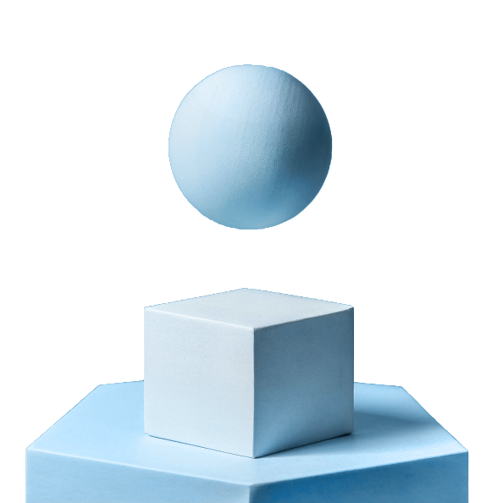

Figure 1: Title of figure (Arial, 10 pt, centre aligned)

Place the table as close as possible to the first reference to them in the paper. They must be numbered using Arabic numbers. Title of the table should be placed above the table, left aligned.

Table 1: Styles in use in the preparation of this document (Arial, 10 pt, left aligned)

Style name | Typeface | Size [pt] | Alignment | Line spacing
Paper title | Arial Bold | 14 | Centred | Single
Author | Arial Regular | 12 | Centred | Single
Address | Arial Regular | 10 | Centred | Single
Abstract text | Arial Italic | 10 | Justified | Single
Figure caption | Arial Regular | 10 | Left | Single
Heading 1 | Arial Bold, Capital | 10 | Justified | Single
Heading 2 | Arial Bold | 10 | Justified | Single
Normal text | Arial Regular | 10 | Justified | Single
References | Arial Regular | 10 | Justified | Single
Table caption | Arial Regular | 10 | Justified | Single

There should be one line spacing before and after the picture or table.

Equations should be centred and numbered consecutively, from 1 upwards. Use Microsoft Equation Editor. There should be one line spacing before and after the equation, Arial,10 pt.

$$ρ=\frac{m}{V}\left[\frac{g}{{cm}^{3}}\right]$$

REFERENCES
References should be listed at the end of the text. In the text, the reference should be placed at the end of the sentence, e. g. (Surname of the first author, year). The list of references (see instructions below) should be arranged alphabetically according to the first author.

References:

Book
Surname, N., Surname, N. and Surname, N. Year. Book Title: The Subtitle. Place: Publisher.

Chapter in a book
Surname, N., Surname, N. and Surname, N. Year. “Chapter Title.” In Book Title, edited by Name Surname, Name Surname, xx−yy. Place: Publisher.

Journal
Surname, N., Surname, N. and Surname, N. Year. “Article Title: The Subtitle.” Journal xx (yy): xx−yy.

Online
Surname, Name. Title: The Subtitle. URL: htttp://xxxxxxxxxx/ (last accessed on xx. yy. zzzz).

Proceedings
Conference proceedings should be treated like a chapter in a book. If published in a journal, treat as an article.

Paper
Surname, N., Surname, N. and Surname, N. Year. “Title of Paper.” Paper presented at the…, Place, Month xx–yy.

Thesis
Surname, N. Year. “Title of Thesis.” PhD diss., University of Ljubljana.

ADITIONAL DATA ABOUT Authors
At the end of the paper provide:
1. Corresponding Author name and surname, Title, Full address, E-mail, Phone, Fax and homepage.
2. Co-author(s) name(s) and surname(s), Titles, Full addresses, E-mails, Phones, Faxes and homepages.

SENDING THE PAPER
Use the surname(s) of author(s) to identify your soft-copy file, e.g. pusnik_urbas_cigt.docx.

Please send your Paper (camera ready) to:

e-mail: cigt@ntf.uni-lj.si

Visual aids at conference
Visual Aids: PC and projector for PowerPoint or PDF presentations and overhead projector.

Corresponding author:

Name SURNAME
University/Company, Faculty, Department/Laboratory
Address of Institution/Company
Postal code, city, State
phone: fax: e-mail:

Co-author(s):

Name SURNAME
University/Company, Faculty, Department/Laboratory
Address of Institution/Company
Postal code, city, State
phone: fax: e-mail:

Name SURNAME
University/Company, Faculty, Department/Laboratory
Address of Institution/Company
Postal code, city, State
phone: fax: e-mail:

