Subject: START:IP – Cutting-edge technology for experienced founders
Dear researchers,

You have developed a technology with a promising market potential? However, you do not want to or are able to start a company on your own with that technology?

Then we have an interesting offer for you:

WHAT IS START:IP?
START:IP was initiated by INiTS, the Viennese business incubator, to support researchers and technology transfer managers of universities, research institutions as well as other technology providers in the commercialization of their cutting-edge technologies.
The objective is to identify leading edge technologies as well as experienced founders, bring them together and enable the entrepreneurs to transform these third party technologies into their own business.

WHICH TECHNOLOGIES ARE WE LOOKING FOR?
We are looking for technologies from any sector, e.g. mechatronics, information and communication technology, materials science and engineering technology, medical technology, biotechnology and others. It should be feasible to launch the first product version in the market within 3 years.

WHAT ARE YOUR BENEFITS?
As a researcher, you have the opportunity to help your “baby” to break into the market with manageable time resources from your side and without any risk.

WHAT DO WE EXPECT FROM THE RESEARCHER?
You should be willing to provide the necessary resources, especially your know-how for further product development till the market entry. As a first step, you should be able to attend the team building event scheduled in Vienna on October, 17th 2018 from 09:00 – 17:00.
The researcher is not expected to take part in the business nor does she/he have to enter an employment- or any other contractual relationship with the “to-be” established startup.

HOW DOES THE TIME SCHEDULE LOOK LIKE?
After the scouting and selection of technologies researchers and potential entrepreneurs are meeting for a one-day team building event. On that day scientist will also present their inventions & technologies. The event itself will be managed in cooperation with Mercuri Urval, a renowned human resources company. Thereinafter the founders team will develop the best possible business model and present it to the public in January 2018.
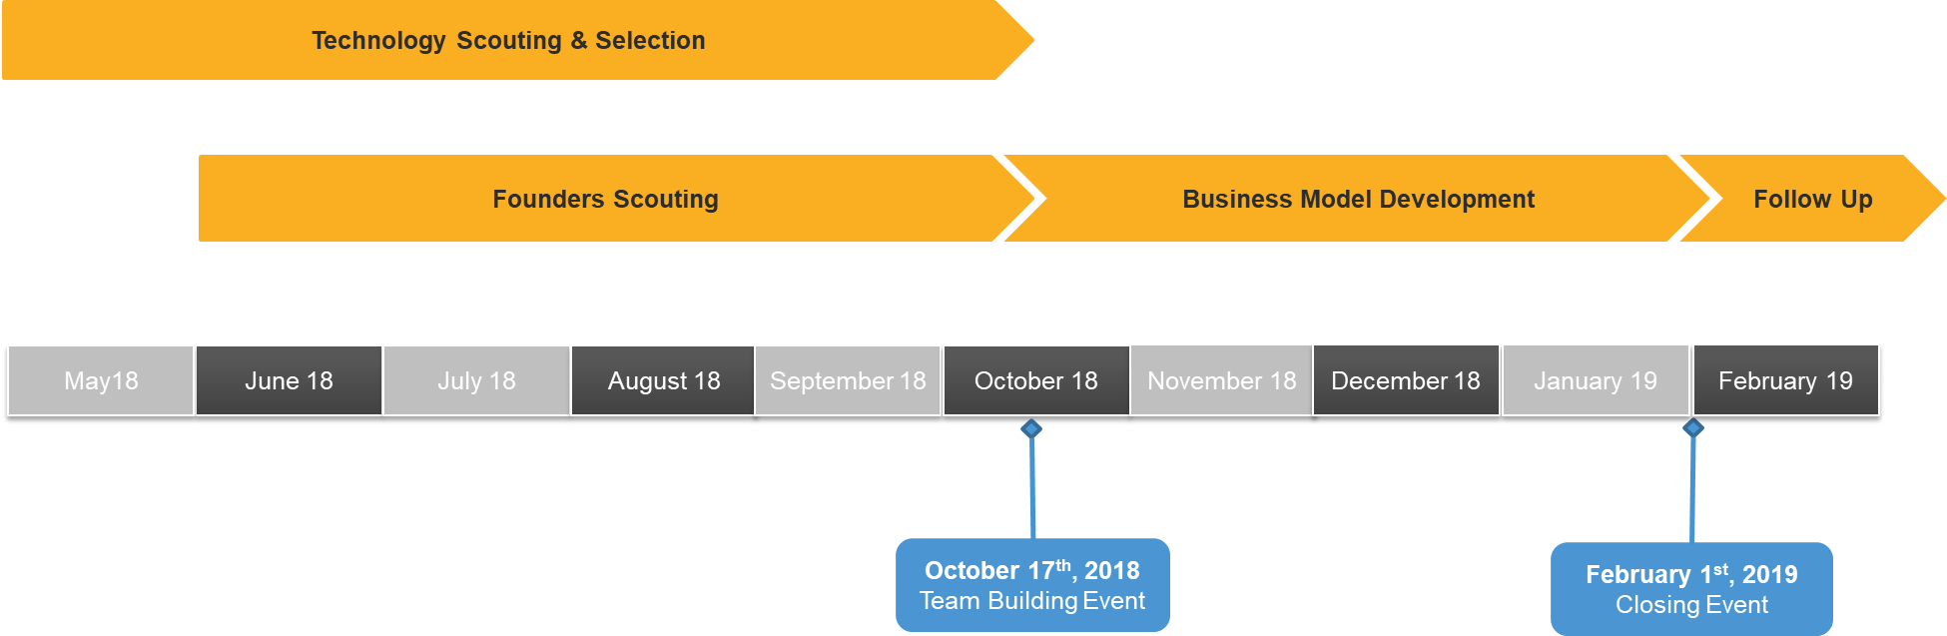

How to register a TECHNOLOGY FOR START:IP?
Only technology transfer offices of universities, research institutions and other technology providers are entitled to propose technologies (Deadline: August, 31st 2018).
For further questions, please contact your technology transfer office.

