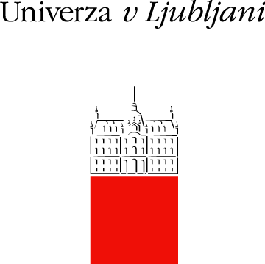

University of Ljubljana (Univerza v Ljubljani, UL) is is the oldest, largest, and internationally best ranked university in Slovenia, being among the top 500 universities according to the ARWU Shanghai ranking. The university was established in 1919 and encompasses 23 faculties, 3 art academies and 3 associated members.

STUDY - by number of students UL ranks among the largest HEI in Europe with more than 40.000 students. It covers all ISCED areas in the first and second cycle study programs and leads the way in some new developments in technology and research (cognitive science, nanotechnologies, environmental sciences, biomedicine etc.). By number of employees UL ranks as medium-sized HEI and employs approximately 5.700 employees, with more than 3.500 academic staff.

HR EXCELLENCE - from 2008 UL is committed to respect the principles of the European Charter for Researchers and the Code of Conduct for Recruitment of Researchers, which led to the award of the “HR Excellence in Research” in 2013.

RESEARCH ACTIVITY - UL is very active in national and international R&D and educational programmes, and creates almost half of the research results of Slovenia. In 2018 UL researchers worked in 307 research groups on 163 national research programmes, 331 national research projects with more than 4.105 registered researchers.

INTERNATIONAL RESEARCH - UL is also very active in international research and education programs. In the programming period 2007-2013 University of Ljubljana altogether cooperated in 745 European projects, including 163 FP7 projects, which rank UL on the first place in the EU-13 countries among the research organisations (source MIRRIS). In 2018 UL was involved in 458 European projects, including 98 running ERASMUS+ KA2 projects and 33 projects in the European territorial cooperation programme. University of Ljubljana was involved in 90 running HORIZON2020 projects, including 4 ERC grants and 15 Marie Sklodowska Curie Actiones.

TTO - To protect the university intellectual property developed through the public financed research projects and to improve the technology transfer from the university to the industry, a central university Technology Transfer Office was established in 2007. University develops and accelerates the research also through the University Committee for R&D, and Committee for Innovation, which consist of representatives of most propulsive Faculties. University Incubator and Institute for Innovation and Development and the Slovenian Innovation Hub are three other units in which University of Ljubljana supports innovation and development in different ways along with laboratories and other research units within Faculties.

Membership in UNICA, Utrecht Network (UN), European University Association (EUA), CEEPUS, the Guild, CELSA, LERU CE7, Central European Exchange Program, CEI University network, SAR Scholars at Risk and Rector’s Conference Alpe Jadran.

