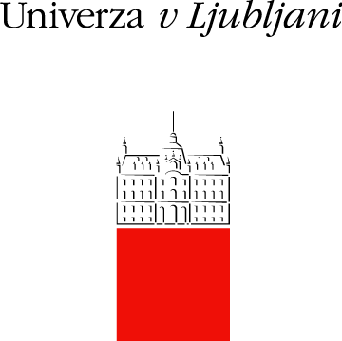

University of Ljubljana (Univerza v Ljubljani, UL) is is the oldest, largest, and internationally best-ranked university in Slovenia, being among the top 500 universities according to the Academic Ranking of World Universities Shanghai ranking (ARWU). The university was founded in 1919 and encompasses 23 faculties, 3 art academies, and 3 associated members.

STUDY – In terms of the number of students, UL ranks among the largest HEI in Europe with more than 40.000 students. In terms of the number of employees, UL ranks as medium-sized HEI and employs approximately 6.000 employees, with more than 3.500 academic staff. Study programmes at UL cover all ISCED areas in the first and second cycle study programmes and leads the way in some new developments in technology and research (cognitive science, nanotechnologies, environmental sciences, biomedicine, etc.).

HR EXCELLENCE - From 2008 UL is committed to respecting the principles of the European Charter for Researchers and the Code of Conduct for Recruitment of Researchers, which led to the award of the “HR Excellence in Research” in 2013.

RESEARCH ACTIVITY - UL is very active in national and international R&D and educational programmes, and creates almost half of the research results of Slovenia. In 2019 UL researchers worked in 307 research groups on 168 national research programmes, 403 national research projects with more than 4.252 registered researchers.

INTERNATIONAL RESEARCH - UL is also very active in international research and education programmes. In the programming period 2007-2013, the UL altogether cooperated in 745 European projects, including 163 FP7 projects, which ranked UL in the first place in the EU-13 countries among the research organisations (source MIRRIS report). In 2019, UL was involved in 528 European projects. Up to now, the UL has been involved in 155 HORIZON2020 projects (including 4 ERC grants, 1 ERA-CHAIR, 1 Twinning project and 24 Marie Skłodowska-Curie Actions), 164 ERASMUS+ KA2, K3, Jean Monnet and Sport projects and 107 projects of the European territorial cooperation programme.

TTO - To protect the university intellectual property developed through the public financed research projects and to improve the technology transfer from the university to the industry, a central university Technology Transfer Office was established in 2007. University develops and accelerates the research also through the University Committee for R&D, and Committee for Innovation, which consists of representatives of most propulsive Faculties. University Incubator and Institute for Innovation and Development and the Slovenian Innovation Hub are three other units in which the University of Ljubljana supports innovation and development in different ways along with laboratories and other research units within Faculties.

Membership in EUTOPIA, the Guild, CELSA, LERU-CE7, UNICA, Utrecht Network, European University Association (EUA), CEEPUS, Central European Exchange Program, CEI University network, SAR Scholars at Risk and Rector’s Conference Alpe Jadran.

