EUROPEAN COMMISSION
DIRECTORATE-GENERAL FOR COMMUNICATIONS NETWORKS, CONTENT AND TECHNOLOGY

Artificial Intelligence and Digital Industry
Technologies and Systems for Digitising Industry

European Digital Innovation Hubs in Digital Europe Programme
Draft working document
30-03-2020
Type the first subtitle here.

Disclaimer: This is a document to prepare the implementation of European Digital Innovation Hubs in Digital Europe Programme. It is based on the draft Digital Europe Programme regulation and 4 meetings with Member State representatives where these ideas where discussed. It has also been validated with other stakeholders during the 3rd Stakeholder Forum on Digitising European Industry “Artificial Intelligence and Digital Innovation Hubs – beyond 2020”, which took place on 13-15 November 2019 in Madrid. The Digital Europe Programme is subject to approval by the European Parliament and the Council.
This is the last major update of the document. It will stay in “draft” status, and only factual errors will be corrected. The final version of these ideas will be published in the Expression of Interest that will be directed towards the Member States and the Workprogramme of Digital Europe Programme that is under development.
The European Commission cannot be held liable for any of the views expressed in this document.

Summary – European Digital Innovation Hubs
European Digital Innovation Hubs (EDIH) will play a central role in the Digital Europe Programme to stimulate the broad uptake of Artificial Intelligence, High Performance Computing (HPC) and Cybersecurity as well as other digital technologies by industry (in particular SMEs and midcaps) and public sector organisations in Europe. They are one-stop shops that help companies become more competitive with regard to their business/production processes, products or services using digital technologies, by providing access to technical expertise and experimentation, so that companies can “test before invest”. They also provide innovation services, such as financing advice, training and skills development that are needed for a successful digital transformation. Environmental issues will be taken into account, in particular with regard to energy consumption and low carbon emissions.
European Digital Innovation Hubs will have both local and European functions. EU funding will be made available for hubs that are already (or will be) supported by their Member States (or regions), so as to increase the impact of public funding. The Digital Europe Programme will increase the capacities of the selected hubs to cover activities with a clear European added value, based on networking the hubs and promoting transfer of expertise. Member States have an essential role in the selection process of the EDIHs; the initial network of EDIHs will be established from a list of hubs designated by Member States.
This document explains how the Digital Europe Programme will be implemented, how it complements the support to digital transformation of the economy under other EU programmes, and how it contributes to a successful network of hubs covering all regions of Europe.
Due to uncertainties about the finalisation of the negotiations between the European Parliament, Council and Commission on the Multi-annual Financial Framework in general and the Digital Europe Programme in particular it is not known yet when the Expression of Interest will be launched. However, a draft timing is the following: The first restricted call for EDIHs is expected to be launched in the 4th Quarter of 2020 so that the selected EDIHs can start their operation in 2021. This implies that Member States should be ready to designate their hubs to the Commission by September/October 2020.
Focus on industry and public services administrations

Co-investment with Member States and Regions
EU support for one DIH per region as a proxy

Figure 1. Digital Europe for Digital Innovation Hubs at a glance
A strong European network of DIH
Focused on HPC, AI, Cybersecurity, Digital Skills
Table of Contents

1. Context 5
1.1. Further need for digital transformation 5
1.2. Digital transformation and the strategic challenges today 6
1.3. What is a European Digital Innovation Hub? 6
1.4. Organisations involved in a European Digital Innovation Hub 8
1.5. Digital Europe Programme knowledge transfer mechanisms 9
1.6. EDIHs for public sector: digital service infrastructures (DSIs) and interoperability solutions 10
1.7. Foreseen use cases for networking of EDIHs 11
1.8. Relationship with other programmes 12
2. Implementation of European Digital Innovation Hubs 14
2.1. Size of the network of European Digital Innovation Hubs 14
2.2. Co-investment principles 15
2.3. Compliance with state aid 16
2.4. Investments from the private sector 17
2.5. EDIHs have a focus/expertise 18
2.6. Mechanisms for networking / collaboration: the Digital Transformation Accelerator 20
2.7. Performance monitoring and KPI’s 22
3. Access to Digital Europe funds 24
3.1. Grants 24
3.2. 2-step selection process of the hubs 24
3.2.1. Expression of interest to Member States 25
3.2.2. Restricted Call by the European Commission 28
3.2.3. Evaluation process after the deadline 31
3.2.4. Extending the initial network during year 2 and 3 32
3.3. Evaluation criteria used for restricted call 32
3.4. What is expected of the proposal? 33
3.4.1. Section Relevance 33
3.4.2. Section Implementation 34
3.4.3. Section Impact 35
4. Conclusions: European added value for supporting hubs in Digital Europe 36
Annex - 37
5. The current landscape of Digital Innovation Hubs 37
5.1. Innovation experiments in Horizon 2020 37
5.2. Digital Innovation Hubs across the EU 38
5.3. Covering white spots and expanding the network 38
6. Annex - Seamless collaboration between Enterprise Europe Network and European Digital Innovation Hubs 38
6.1. Introduction to Enterprise Europe Network 38
6.2. Foreseen co-operation between the two networks 41
7. Annex – Declaration of cooperation on smart and sustainable digital future for European agriculture and rural areas on Agriculture 42

Table of Figures

Figure 1. Digital Europe for Digital Innovation Hubs at a glance 2
Figure 2. Level of digitalisation and adoption of eGovernment 5
Figure 3. Main functions of European Digital Innovation Hubs 8
Figure 4. The programmes complement each other 14
Figure 5. EDIH focus 19
Figure 6. Schematic overview of the role of EDIHs in Digital Europe Programme. Networking will be animated by the “Digital Transformation Accelerator” 20
Figure 7: 2 step selection process of EDIHs 24
Figure 8. Added value of combining local and European investments 36
Figure 9 Business Cooperation Centers of the Enterprise Europe Network 38
Figure 10. : Services of the Enterprise Europe Network consortia 40

Context

Further need for digital transformation
The digital transformation of the economy is key for Europe to remain competitive internationally. Our companies and public sector organisations need to integrate digital technologies into their business processes, products, and services to fully benefit from the efficiency gains and innovation they may bring, while remaining environmentally sustainable and reducing greenhouse gas emissions. In particular, the smart use of data can be a powerful lever to drive growth, create new jobs and open up new business models and innovation opportunities. Three years after the launch of the Digitising European Industry Strategy and the eGovernment Action Plan, European economy has made significant progress. The level of digitalisation however remains uneven, depending on the sector, country and size of company: only 20% of SMEs in the EU are highly digitised. A similar pattern is observed for the adoption of eGovernment, where the overall adoption of eGovernment services is 53%, with some countries reaching more than 75% and other countries still below 30% (see Figure 2). European Digital Innovation Hubs have a key role to play to address these gaps.

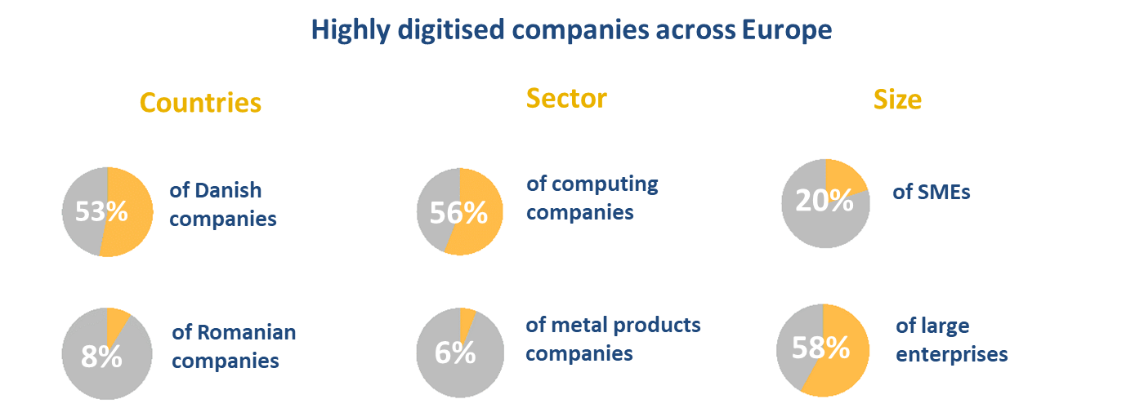

Source: DESI, 2018
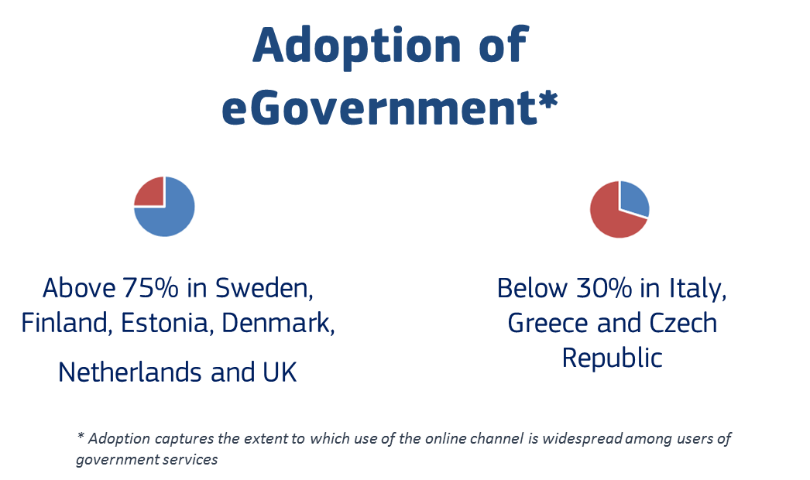
Source: eGovernment Benchmark Insight Report, 2018
Figure 2. Level of digitalisation and adoption of eGovernment

Digital transformation and the strategic challenges today
With the communication of December 2019, the European Commission has committed to “tackling climate and environmental-related challenges that is this generation’s defining task”, and defined a set of strong measures aiming at getting no net greenhouse gases emissions by 2050 and decoupling economic growth from resource use.

Meeting these objectives will require significant technological advances in several areas, and digital technologies will be a key tool to improve efficiency and sustainability of any aspect of our lives. The network of European Digital Innovation Hubs should therefore help companies of any size to get access to the digital technologies they need to contribute to the European Green Deal.

A second, very recent, problem is threatening Europe and the world today. The global epidemic of COVID-19 is imposing a heavy toll in terms of human lives, and is also showing its negative impact on the economy. The recent events have also clearly shown how digital technologies enable resiliency for the society at large, e.g. by allowing remote communications of important information and supporting solutions like large-scale teleworking.

There is little doubt that the coming months will see a significant economic crisis. It is important that, as soon as the conditions for an economic recovery will mature, European companies will be ready to exploit the future opportunities, and for this they have to be equipped with the digital technologies they need and the know-how to make the best use of them. A working network of European Digital Innovation Hubs will be an important success factor.

What is a European Digital Innovation Hub?
A European Digital Innovation Hub (EDIH) is a single organisation or a coordinated group of organisations with complementary expertise, with a not-for-profit objective that support companies – especially SMEs and mid-caps – and/or the public sector in their digital transformation. EDIHs offer services such as (see Figure 3):
- Test before invest: The Digital Europe draft regulation mentions: “raise awareness and provide, or ensure access to, digital transformation expertise, know-how and services, including testing and experimentation facilities”. The group of services enabling test before invest may include: awareness raising, digital maturity assessment, demonstration activities, visioning for digital transformation, fostering the integration, adaptation and customisation of various technologies, testing and experimentation with digital technologies (software and hardware), knowledge and technology transfer. Special focus will be on the key technologies promoted in Digital Europe Programme: HPC, AI, and Cybersecurity.
- Skills and training: The draft regulation mentions: “They will also provide support in the area of advanced digital skills (e.g. by coordinating with education providers for the provision of short-term training for workers and internships for students)”. To ensure the appropriate level of digital skills within the supported organisations in order to make the most of digital innovations technologies, EDIHs' services should include advertising, hosting or providing of training, boot-camps, traineeships, as well as supporting the implementation of the short-term advanced digital skills training courses and job placements developed as part of the DEP Advanced Digital Skills pillar.
- Support to find investments: The draft regulation mentions “to support companies, especially SMEs and start-ups, organisations and public administrations to become more competitive and improve their business models through use of new technologies covered by the Program”. Therefore, this category of services may include: access to financial institutions and investors, supporting the use of InvestEU and other relevant financing mechanisms, in close co-operation with the foreseen InvestEU Advisory Hub and the Enterprise Europe Network (EEN). For the public sector in particular, as one of the largest purchasers of ICT, this service could furthermore provide support to leverage the purchasing power of the public sector, transforming it into a large innovation buyer.
- Innovation ecosystem and networking: The draft regulation mentions: “European Digital Innovation Hubs should act as facilitator to bring together industry, businesses and administrations which are in need of new technological solutions on one side, with companies, notably start-ups and SMEs that have market-ready solutions on the other side”. No company can innovate alone. It will help companies greatly if they are brought into contact with other companies of their value chain, with innovators, or early clients that want to test solutions. EDIHs should play this brokering role and bring e.g. end-users and potential suppliers of technological solutions into contact with each other for e.g. experimentation and testing, or public administrations and GovTech companies to promote co-creation. The non-profit objective of EDIHs is important in this respect, and they might promote local companies to improve the overall economic strength of their local economy. When suitable local partners may not be found, the hubs can network with other EDIHs to find a matching partner elsewhere in Europe. Hubs can only become good brokers if they do regular technology scouting, in order to map the innovation ecosystem, and understand needs and opportunities. Structured relationships with regional authorities, industrial clusters, SME associations, business development agencies, incubators, accelerators, EEN, EIT Co-location Centres, and chambers of commerce will greatly help the brokering function.

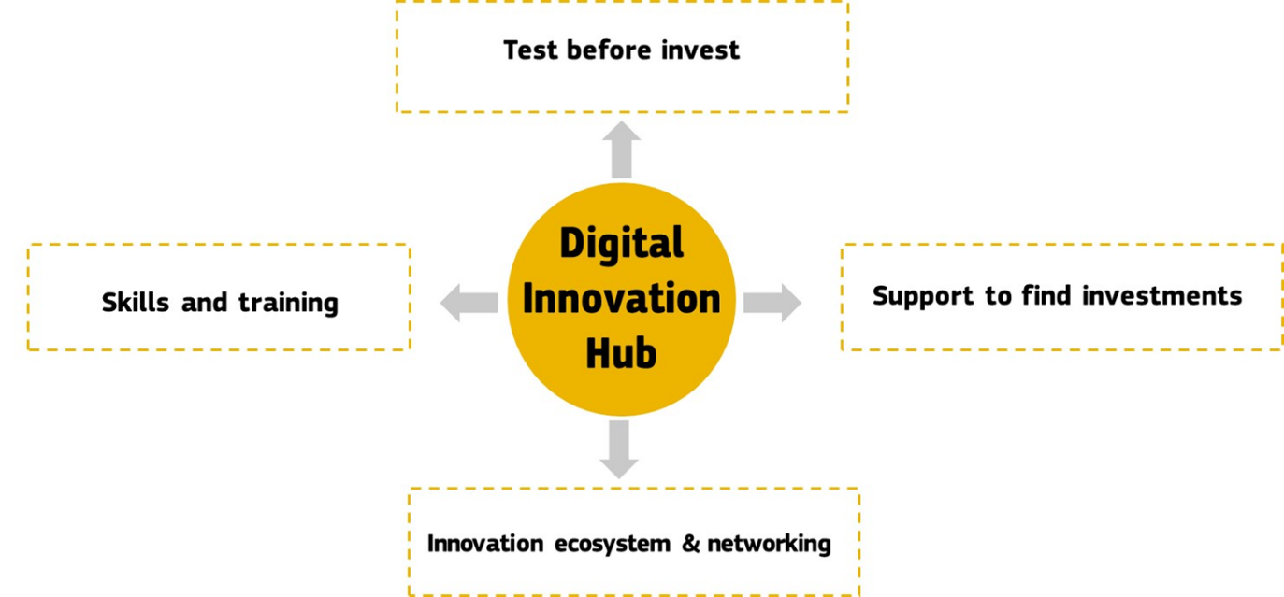
Figure 3. Main functions of European Digital Innovation Hubs

The services of the EDIHs should be complementary to and not replace existing (commercial) services of e.g. training suppliers or ICT companies. Through the function “Innovation ecosystem & Networking”, a hub works also as a broker and matchmaker between needs of certain companies and possible suppliers. Suppliers can be involved in the “Test before invest” or “Skills and training” activities. Hubs may give preference to local SMEs as suppliers, and if these are not available, to other European SMEs, in line with their procurement rules and equal opportunities need to be provided to all potential suppliers. Such companies do not need to be part of the consortium of beneficiaries of the grant, but these could be involved through subcontracting.

Organisations involved in a European Digital Innovation Hub
The draft regulation mentions: “(4a) European Digital Innovation Hubs shall have substantial overall autonomy to define their organisation, composition, and working methods” and “(11b) A consortium of legal entities may be selected as European Digital Innovation Hubs […].”

While EDIHs are free to define their organisation, composition, and governance structure, they should cover at least the technology side and the business development side, and be capable of doing effective outreach. They should also have appropriate links to companies and/or public sector organisations. At the core of the EDIH, there is normally a research & technology organisation (RTO) or university lab offering technology services. They often work in collaboration with partners whose expertise lies in business development/public sector innovation or training in order to provide innovation services as well as with partners (such as for example chambers of commerce, clusters, industry associations, the Enterprise Europe Network (EEN), incubators, EIT KIC, vocational training centres or others). EEN could help find investors / finance providers, while a regional cluster could help companies tap into international markets. Links with incubators/accelerators might be useful to involve start-ups in the ecosystem, and industry associations to understand requirements and future needs and digital suppliers. EIT KIC or clusters could also be the basis of an EDIH, if they are willing and able to fulfil the tasks that an EDIH needs to carry out. A seamless service is expected between different initiatives funded by the European Commission, such as the EEN and the EDIHs. Annex 6 explains this in more detail.

In order to benefit from DEP funding, the European Digital Innovation Hubs may create a consortium of legal entities; their collaboration may be governed by a consortium agreement or similar. There is no obligation to create a dedicated legal entity. An EDIH should have a local presence, but it is allowed to collaborate with organisations from other regions for the purpose of creating a well-balanced and effective consortium.

There is also a role to play for large corporates. Often such companies work together with a large number of (SME) suppliers. Large corporates could therefore be involved in defining some of the services of the EDIH to make sure that local industry profits from digital transformation; a stronger local industry is beneficial to smaller and bigger companies alike. Also large corporates could make in-kind contributions to the hub, e.g. software and equipment for “test before invest”. They can also sponsor the hub further, provided that the not-for-profit objective and the neutral brokering role of the hub remains.

The involvement of other partners, like creatives or artists could be considered. They could help to embed digital better in the creative sector but equally to help shape new practices of human-machine co-existence in specific industry sectors. Often lack of awareness of consequences of use of digital technologies – like fear of loss of control or of working conditions in presence of digital technology – are hindering uptake as much as lack of technological skills. The digital sector can profit from the cultural and creative industries to bring a new perspective to the sector.

If a hub until now was only focused on private sector, but in the future would like to serve public administrations as well, it can consider including organisations dedicated to public administration and public sector innovation in their consortium.

Digital Europe Programme knowledge transfer mechanisms
The Digital Europe Programme will focus on capacity building in high performance computing (HPC), cybersecurity and artificial intelligence (AI), related advanced digital skills as well as digital solutions / interoperability for the public sector. Technologies and knowledge developed under Specific Objectives 1, 2 and 3 will be made available by HPC Competence Centres, Cybersecurity National Coordination Centres, and AI Reference sites. Specific Objective 4 will create an offer of trainings and job placements available for the different target groups. Specific Objective 5 will deliver digital service infrastructures for areas of public interest. To make sure that those capacities are actually used by companies and public administrations, European Digital Innovation Hubs will work closely with the relevant specialised centres or consortia responsible for the different DEP projects and make sure that companies and public administrations can experiment with those technologies and apply them according to their needs. For example,
- the hubs can help SMEs to make use of the advanced computing facilities of the HPC centres;
- the hubs can also promote the AI-on-demand platform, which makes AI algorithms and public data sets available for anyone. EDIHs can help SMEs to experiment with this platform, and identify those datasets and algorithms that are relevant for the needs of those companies;
- another important activity are the security audits for SMEs. Here also, the EDIHs should promote this to their stakeholders;
- Related to training, the EDIHs may be one of the organisations selected to provide short-term training courses or they may just host them for organisations in their area. In any case, they should advertise the available trainings that are relevant for their stakeholders. The hubs should also promote job placement opportunities to their network of SMEs / public administrations;
- Section 1.4 describes in more detail some examples of EDIH activities for the public sector.

Special horizontal support activities are foreseen to support the necessary knowledge transfer from the Specific Objectives towards the EDIHs and vice versa (see Section 2.6)

EDIHs for public sector: digital service infrastructures (DSIs) and interoperability solutions
Modernising public administrations and services through digital means is crucial to reducing administrative burden on the private sector and on citizens in general by making their interactions with public authorities faster, more convenient and less costly, as well as by increasing the efficiency and the quality of the services provided to citizens and businesses.

Interoperability of European public services concerns all levels of administration: Union, national, regional and local. Besides removing barriers to a functioning Single Market, interoperability facilitates successful implementation of policies and offers great potential to avoid cross-border electronic barriers, further securing the emergence of new, or the consolidation of developing, common public services at Union level. In order to eliminate fragmentation of European services, to support fundamental freedoms and operational mutual recognition in the EU, there must be a holistic cross-sector and cross-border approach to interoperability, which is promoted in the manner that is the most effective, and the most responsive to end-users. This implies that interoperability is to be understood in a broad sense, spanning from technical to legal layers and encompassing policy elements in the field.

Digital Europe Programme foresees to deploy the so-called “Transformation Platform Ecosystem”, which includes the European Digital Service Infrastructures and building blocks (eID, eInvoicing, eDelivery, eSignature, context broker, etc.), interoperability solutions (eHealth patient summary and ePrescription), as well as the Open Data Platform, which can serve both the public and the private sector.

EDIHs could serve local and regional public administrations and other public sector organisations that aspire to use the Transformation Platform Ecosystem, to be compliant with the Principles of the Tallinn declaration on E-Government. Furthermore, EDIHs could help public administrations to use other agreed standards and open source solutions, access government platforms or shared infrastructures (offered on the European or MS level), experiment with Artificial Intelligence and Blockchain for real-time policy-making (e.g. traffic optimisation), or help public administrations improve their cybersecurity. In this context, EDIHs could in particular assist public authorities/buyers to fully use the potential of procuring innovation, and bring them into contact with companies that are ready to supply the necessary digital technology solutions ('technology providers'), stimulating further the development of the local ecosystem.

Not all EDIHs will need to support the public sector, but in the overall network, there needs to be a reasonable amount that do.

Foreseen use cases for networking of EDIHs
Digital Europe will support the European DIH network and EDIH collaboration to, for example, build EDIHs’ local capacity to serve more than one region/country, to export a DIH’s excellence, and to connect ecosystems.

- Exporting / Importing EDIH excellence: Based on complementary competence and infrastructure, EDIHs could export their specialisation to SMEs in other MS, in the form of opening up their facilities and knowledge to clients outside of its own region. Vice versa, if an EDIH misses certain expertise or facilities to support its own regional clients they can ask the support of other EDIHs who would have this expertise, and that way import expertise offered by other EDIHs. This could be done on an individual basis, starting from the needs of individual customers, but also in a more proactive way where several hubs together combine their knowledge and facilities to develop common services for their stakeholders.
- Connecting ecosystems: Just like EDIHs at the local level build ecosystems by bringing into contact actors along the value chain to develop new innovations, at a European level several hubs can connect different ecosystems together by identifying innovation opportunities for users and suppliers coming from different regions. This will help SMEs expand and tap into other markets, develop EU value chains, create new business opportunities for companies or help commercialise earlier innovation experiments or pilots. Also other types of common interest projects (e.g. open platforms, standards, standardised services, shared infrastructure, etc.) in collaboration with companies and stakeholders from the different regions can connect ecosystems and will help avoid unnecessary duplication of investment or give access to infrastructure at a lower cost.
- Common investments: Member States and Regions may decide to invest together in common EDIHs. The European Grouping of Territorial Cooperation (EGTC) could be an appropriate legal instrument for such cross-border cooperation, as it enables regional and local authorities and other public bodies from different member states, to set up cooperation groupings with a legal personality. Partnerships around related Smart Specialisation priorities that have emerged as part of the three thematic Smart Specialisation Platforms, some of which were inspired by the Vanguard Initiative collaboration model, could be a starting point for such joint EDIH initiatives.

These activities will lead to hubs learning from each other and therefore greater cohesion in the capabilities of the hubs to help their customers with their digital transformation.

Relationship with other programmes
Digital Transformation will not only be supported under the Digital Europe Programme, but also through Horizon Europe, and European Regional Development Funds. Furthermore, there will be dedicated financial instruments in InvestEU to support the uptake of advanced digital technologies such as AI and Blockchain. Every programme focuses on particular aspects and there is a clear delineation between them, as explained in the following section (see Figure 4).

Digital Europe programme: This programme is focused on investments in digital capacities, and as such, the funding foreseen for European Digital Innovation Hubs will be directed towards the hubs, with the objective that they invest in their capacity, i.e. latest equipment and facilities as well as employees to deliver services to their stakeholders. All selected hubs will be networked, in order to obtain European added value, in the form of rationalisation of investments and sharing best practices. The selection process will be partly done together with the Member States, and the objective is to ensure a broad geographical coverage across Europe.

Horizon Europe programme: This is the framework programme for Research and Innovation. It is foreseen to continue with activities that were already present in H2020, such as ICT Innovation for Manufacturing SMEs (I4MS). These activities are directed towards companies that work together with Digital Innovation Hubs to experiment and test with novel digital solutions to improve their businesses. Organisations that participate in the test-before-invest experiments will be eligible for funding. European Digital Innovation Hubs may participate to these projects, just like other types of Digital Innovation Hubs or organisations with the appropriate knowledge.

European Regional Development Fund (ERDF) post-2020: Through its policy objective “A smarter Europe by promoting innovative and smart economic transformation”, ERDF programmes may support Digital Innovation Hubs mainly in four ways:
- construction and up-grading via investments in infrastructure, equipment, software and intangible assets,
- research and innovation services for SMEs, including transfer of advanced digital technologies,
- delivering digitalisation services to SMEs and public sector, etc.
- strengthen the regional and local innovation ecosystems including the participation of DIHs in the entrepreneurial discovery processes for smart specialisation.
A prerequisite for investments of ERDF in Digital Innovation Hubs for services under categories “Test before invest (in digital technologies)” and “(Digital) skills and training” is that, these are fully supporting the regional or national smart specialisation strategy.

New in the future ERDF programme is that interregional investments are encouraged through a new Interregional Innovation Investment Instrument, called the European Grouping of Territorial Cooperation (EGTC), see Section 1.7. Therefore, several regions (possibly coming from different Member States) may also decide to invest together in Digital Innovation Hubs or use the hubs for developing innovations along shared value chains.

ERDF and Digital Europe Programme can be combined for European Digital Innovation Hubs. The ERDF may not be used to fund maintenance and operating costs of DIHs.

European Agricultural Fund for Rural Development post-2020: Based on the post-2020 CAP (Common Agriculture Policy) proposal national and/or regional authorities may use Art. 68-Investments and Art 71- Cooperation to support for various types of digital operations for agriculture and rural development, such as small-scale digital infrastructure, equipment, software and intangible assets, cooperation and innovation services. Therefore, DIHs focusing on agriculture and/or rural development may be funded through these means, and EAFRD may also be used for co-funding EDIHs in these areas, provided there is no double funding of some cost items. The administrative or the electronic crosschecking controls fall under MS responsibility.

InvestEU Programme builds on the successful model of the Investment Plan for Europe, the Juncker Plan. It will mobilise public and private investment using an EU budget guarantee. There will be dedicated financial instruments to support the digital transformation, and in particular StartUps/ScaleUps in the area of AI and blockchain, and the uptake of these technologies by traditional companies. Financial intermediaries such as banks or equity investors will integrate these instruments in their offer.

The foreseen synergies with European Digital Innovation Hubs and InvestEU is that the hubs help to overcome a knowledge gap in financial intermediaries and companies: from the side of financial intermediaries it is difficult to estimate the risks associated with investments in digital technologies, and from the side of companies it is difficult to estimate costs and expected return on investments.

Therefore, when EDIHs have supported companies to test certain innovations and the companies decide to invest further, the hubs can bring them into contact with the right financial intermediary. The “test before invest” service allows a company to make a realistic return on investment scenario that can help financial institutions to make a better decision. It will also be easier for companies to estimate the level of investments they need and to convince the investor that they are appropriately equipped to make the best of the investment.

Figure 4. The programmes complement each other
Allocated at national level
Digital Europe: Support to the facilities and personnel of the European Digital Innovation Hubs, to build capacity in Europe to diffuse digital innovations across SMEs and administrations.

European Regional Development Fund: Investments allocated by the Member States to build-up or strengthen the Digital Innovation Hubs infrastructures in their territories and reduce the digital divide. ERDF can be used by Member States to co-invest on EDIHs in Digital Europe.
InvestEU: Incentives and risk reduction programmes to help companies find follow-up investment to further complete their digital transformation. The work of the digital innovation hubs will diminish the knowledge gap that exists.
Horizon Europe: Support to SMEs and mid-caps to experiment with highly innovative digital technologies in a cross-border setting. European Digital Innovation Hubs and others may apply for these grants, and cascade a large part of the funding to SMEs
Allocated at European level
European Agriculture Fund for Rural Development: Investments allocated by Member States to foster knowledge transfer and innovation in agriculture, forestry and rural areas. EAFRD can be used by Member States to co-invest on EDIHs in Digital Europe.

Implementation of European Digital Innovation Hubs
This chapter will focus on design principles of the EDIHs. It especially highlights some principles that are put forward in the draft regulation or that have been discussed with the Member States in one of the preparatory meetings.

Size of the network of European Digital Innovation Hubs
The draft regulation states that the “network of European Digital Innovation Hubs should ensure a broad geographical coverage across Europe and should also contribute to the participation of the outermost regions in the Digital Single Market”.

Digital Europe Programme is an investment programme in digital capacities and wants to make an impactful contribution to the capacity of European Digital Innovation Hubs. The Commission therefore proposes to invest between 0,5 and 1M€ per year in each hub. Together with the contribution of the MS, this would add up to a significant investment between 1 and 2 M€ per year per EDIH. With the current budget proposal for Digital Europe, it is foreseen to support between 130 – 260 hubs in the EU, with at least one hub per Member State. These numbers will be adapted once the final budget is agreed with the European Council and Parliament.

For the geographical distribution, it is proposed to leave maximum flexibility to the Member States. Every Member State will get as a maximum amount of co-funding of the EDIHs in their country a pre-defined share of the overall funding available for EDIHs in Digital Europe Programme, see Section 3.2.1. They subsequently get the opportunity to designate a number of hubs, geographically spread over their territory, that respond to the demand of private and public sector while taking into account existing assets of the country. Member States may propose special measures for the outermost regions. Depending on the needs of individual hubs, it can be decided to invest more in some and less in others.

Co-investment principles
To operate a European Digital Innovation Hub it is necessary that there is (access to) a state-of-the-art physical infrastructure (a building to receive customers, training facilities, showroom / demonstration facilities, testing and experimentation equipment and facilities) that supports the objectives of the hub. Furthermore, qualified personnel is needed to provide services to SMEs and/or public sector organisations.

Member States (possibly together with their industry (see Section 2.4)) and the European Commission will both invest in the European Digital Innovation Hubs. Digital Europe Programme foresees funding in the form of a grant, for a duration of 3 years with the possibility of reapplying at the end of the grant duration, for an additional period of 4 years. After the duration of the grant(s), the capacities built up with the support of the Digital Europe Programme are expected to remain available to SMEs and/or public sector organisations. It is not necessary to achieve full commercial sustainability after the end of the project. Since Digital Europe Programme is a capacity-building programme, the Member State contribution should also aim at supporting capacity building of the EDIH.
Specific cost items that could be funded through the Digital Europe grants
- Procurement and/or depreciation costs for equipment and facilities, both hardware and software
- Qualified personnel of the EDIH for delivering digital transformation services to SMEs or public administrations, including subcontracting for specialists
- Travel grants for hub personnel and local stakeholders to work with other hubs
The Digital Europe grant will fund 50% of the requested amount, capped by the limits explained in section 3.2.1. Member States (or their regions) should contribute at least an equal amount, either in-kind or in-cash, leveraging private funding if necessary. The proposal for the grant needs to justify the requested funding in terms of their expected KPIs on activities with European added value and their expected impact.

Several situations can occur:

- Member States have already built up Digital Innovation Hubs in the past, and want to designate these for Digital Europe Programme: MS can contribute with cash, or in-kind by contributing e.g. personnel or depreciation of previous investments in the hub. If the support was covered by article 27 General Block Exemption Regulation, please note the 10 years time limit for operating aid.

- There is no Digital Innovation Hub yet in the region, and MS will invest in it during Digital Europe Programme. In this case, MS can again contribute in-kind or in cash with the foreseen investments in the hub. If the project on the MS side has a different timing than Digital Europe, a grace period of 1 year is foreseen. At proposal stage, it must only be proven that MSs/regional co-investment is requested. Upon selection, the grant will be signed after the corresponding MS/regional contribution is made available.

Compliance with state aid

Since the selection procedure of EDIHs gives some degree of flexibility and discretion to the Member States, the grants to the hubs need to be considered as a state aid. It is therefore important to be in-line with existing exemptions. The grant is used to reinforce the hub, i.e. to invest in facilities and in personnel. Ideally, all the benefits they receive will be passed on to their stakeholders (SMEs and public sector organisations) in the form of open and accessible services, but it will not be possible to 100% in all cases. Two situations therefore need to be considered:

- Aid to the SMEs
All the services provided by the EDIH free of charge or at a subsidised price should be in line with Art 28 (94-95) GBER: ‘innovation advisory services’ means consultancy, assistance and training in the fields of knowledge transfer, acquisition, protection and exploitation of intangible assets, use of standards and regulations embedding them, and ‘innovation support services’ means the provision of office space, data banks, libraries, market research, laboratories, quality labelling, testing and certification for the purpose of developing more effective products, processes or services;
In Art 28 (4) the GBER regulation states “In the particular case of aid for innovation advisory and support services the aid intensity can be increased up to 100% of the eligible costs provided that the total amount of aid for innovation advisory and support services does not exceed EUR 200.000 per undertaking within any three year period. ” On this basis, any SME would be allowed to use the above services/functions up to a maximum of €200,000. In our view, this €200,000 per SME over a three-year period is well above the expected level of aid. In fact, we expect that a typical SME would stay below 50.000€/three year period. Then the SME can still receive funding from other programmes. An SME that is already close to the upper limit might not be the target group of this measure. For follow up services after the initial services of the hub has been used, SMEs would have to pay a fee at market prices. It is up to the EDIH to determine if they want to provide services for free or at a subsidised price. If a price is charged, this has the benefit that the customer is more consciously choosing to make use of the service, and therefore the capacity of the EDIH is used for organisations that really need it. It is however highly recommended to provide services to the public sector for free. Otherwise they need to use laborious procurement processes to make use of the service.
In order to be able to determine the value of the services received by an SME, every EDIH should in their proposal draw up a price list for all their services, based on market prices if these exist. If these do not exist, they should be based on efforts and associated costs (e.g. a share of the investment costs for which aid was received). The price list would apply to all SME and large enterprises, but only large enterprises would systematically pay. This calculation must already be made in the proposal so that the external experts can evaluate its validity.
- Aid to the EDIHs

The aid that is not passed on to the SMEs, for instance investments in equipment that is not yet fully depreciated, is considered to be aid to the EDIH and should be in line with Art 27 (92) GBER ‘Innovation clusters’. These are defined as structures or organised groups of independent parties (such as innovative start-ups, small, medium and large enterprises, as well as research and knowledge dissemination organisations, non-for-profit organisations and other related economic actors) designed to stimulate innovative activity through promotion, sharing of facilities and exchange of knowledge and expertise and by contributing effectively to knowledge transfer, networking, information dissemination and collaboration among the undertakings and other organisations in the cluster;
The maximum aid per cluster (for its whole lifetime) should be below 7.5M€ (Art 4(1)(k) GBER). Note that only part coming from the MS needs to be taken into account. The part coming from the EU is not considered state aid.
Art 27(2) explains that Aid for innovation clusters shall be granted exclusively to the legal entity operating the innovation cluster (cluster organisation). In the context of EDIH, these are the beneficiaries of the DEP grant. It is not needed that an EDIH is operated by one legal entity, a consortium of legal entities with a consortium agreement detailing the responsibilities and obligations of all partners is sufficient.
Art 27(4) explains that the fees charged for using the cluster's facilities and for participating in the cluster's activities shall correspond to the market price or reflect their costs. However, this is covered by Art. 28 GBER, explained above.

Investments from the private sector

The draft regulation mentions: “European Digital Innovation Hubs should be allowed to receive contributions from Member States, participating third countries or public authorities within them, contributions from international bodies or institutions, contributions from the private sector, in particular from members, shareholders or partners of the European Digital Innovation Hubs, revenues generated by the European Digital Innovation Hubs’ own assets and activities, bequests, donations and contributions from individuals or funding including in the form of grants from the Programme and other Union programmes”.

If a Member States decides to co-invest together with the private sector in the European Digital Innovation Hubs it will be necessary to ensure that the access to the EDIH is open to all users and is granted on transparent and non-discriminatory terms. Furthermore, under State aid rules, an investor that finances at least 10% of the total investment costs may be granted preferential access under more favourable conditions but to avoid over-compensation such access must be proportional to the undertaking’s contribution to the investment costs (and these conditions must be made publicly available). It is also strongly encouraged that Member States use competitive open calls to select potential private co-investor(s) and to test market’s interest in co-investing in a project, thus also avoiding a situation where one private investor/technological solutions would be privileged while other potentially interested private investors would have been discriminated.
In order to avoid the situation where an EDIH is financed by only one investor who has control of EDIH’s activities we recommend that more investors contribute in supporting the EDIH, or alternatively if there is only one private investor, the value of the controlled activities by this investor should not go beyond 20%.
The private sector could for instance provide equipment and software that SMEs can use during “test before invest”, or they can sponsor the EDIH with a cash or in-kind contribution.

EDIHs have a focus/expertise
The draft regulation mentions: “European Digital Innovation Hubs will serve as access points to latest digital capacities including high performance computing (HPC), artificial intelligence, cybersecurity, as well as other existing innovative technologies such as Key Enabling Technologies, available also in fablabs or citylabs.”

Hubs are embedded in a local economy and have as an objective to strengthen it by supporting the digital transformation of the local industry and public sector. If for instance manufacturing is important, the hub could support the companies in adopting Industry 4.0 and circular economy methods. Traditional ICT methods like simulation and supply chain integration will play an important role, and these are becoming more and more based on AI and HPC. Also by introducing digital manufacturing, cybersecurity becomes a prerequisite. This particular hub would therefore have as a focus Industry 4.0/circular economy, using AI, HPC and/or Cybersecurity.

Another example would be a hub in a local economy where construction is important. The potential for digitalisation of the construction sector is very high, since many tasks are still carried out in a manual way. The hub could work with the sector and let relevant companies test brick-laying robots or exo-skeletons, and that way introduce AI in the sector. Figure 5 shows other examples.

DEP | Other Technologies | Application areas | Sector
AI, HPC, or Cybersecurity | Simulation  Supply chain integration  Blockchain,  Advanced Materials, … | Industry 4.0  Circular economy | Manufacturing
 | Remote sensing, Photonics, Life-Science Technologies, … | Precision farming | Agri-food
 | Robotics, Simulation, … | Exo-skeletons, Automated building | Construction
 | Digital solutions for governments Blockchain, … | Services for citizens, once-only principle | Public administration
 | … | … | …
Figure 5. EDIH focus
In general, based on the local strengths available and the future needs of the local industry or public sector, (which could for instance be identified via an entrepreneurial discovery process for the relevant Smart Specialisation Strategy) every EDIH should have or develop a dedicated focus with corresponding expertise during the lifetime of its funding. This should include one or more of the key digital technologies supported under DEP, as these are prerequisites to the digital transformation of the economy and society. Basic competences around these technologies are required, but during the Programme there will be ample opportunities to build up more in-depth knowledge through cooperation with complementary hubs and the specialist projects of Digital Europe Programme. If ERDF is used for co-financing, the specialisation of the hub has to be in line with the smart specialisation of that region. Hubs should also help companies to evaluate the environmental consequences of using digital technologies. Similarly, EAFRD may be used for co-funding EDIHs focusing on agri-food and digitalised agriculture in general.

In case of a very low digital maturity of the companies or public sector organisations targeted by the hub, the hub should adapt its services to first deliver the basic services needed. However, the hub should also offer gradually more specialised services to their stakeholders since also they should benefit from advanced services. In any case, the focus and expertise of a hub should follow the needs of its local stakeholders.

It is important that not all hubs will have the same focus, but that they complement each other across Europe and address the needs of Europe’s economy. Member States therefore need to work together with each other, their hubs and regions to get an efficient coverage of technologies and sectors. The selection process (see Section 3.2.3) will provide a mechanism to ensure such a diverse coverage.

Given the importance of Artificial Intelligence and its wide applicability in all sectors, we expect that at least one of the hubs selected in each country will be specialised in AI. Most Member States have also signed in 2019 the Digital Declaration on smart agriculture and rural areas, see Annex 7, where Digital Innovation Hubs play an important role. These hubs may become European Digital Innovation hubs with a specialisation on digitalised agriculture.

While hubs are strongly linked to the local economy, and should ensure that they are a first contact point for the local industry and public sector, this does not mean that they cannot have customers from other regions of Europe.

As an example, in case a local hub does not have the technical or business competences needed to support an SME, they can help the SME to get in touch with a second hub possibly in a different Member States, and then help them to “bring back home” the acquired expertise. The European network of hubs will avoid unnecessary duplication of efforts and competences by making these exchanges easy, thus potentially allowing hubs to support customers from other regions and Member States. Further information on this subject can be found in the conclusions, Chapter 4.

Mechanisms for networking / collaboration: the Digital Transformation Accelerator
Figure 6 summarises the knowledge transfer in Digital Europe Programme and the networking of the EDIHs, which were explained in Section 1.3 and 1.5. The organisation of this collaboration will be supported through a support facility called the “Digital Transformation Accelerator”. This name signifies the importance of this action: it should animate all networking and collaboration activities and through that accelerate the digital transformation everywhere in Europe.
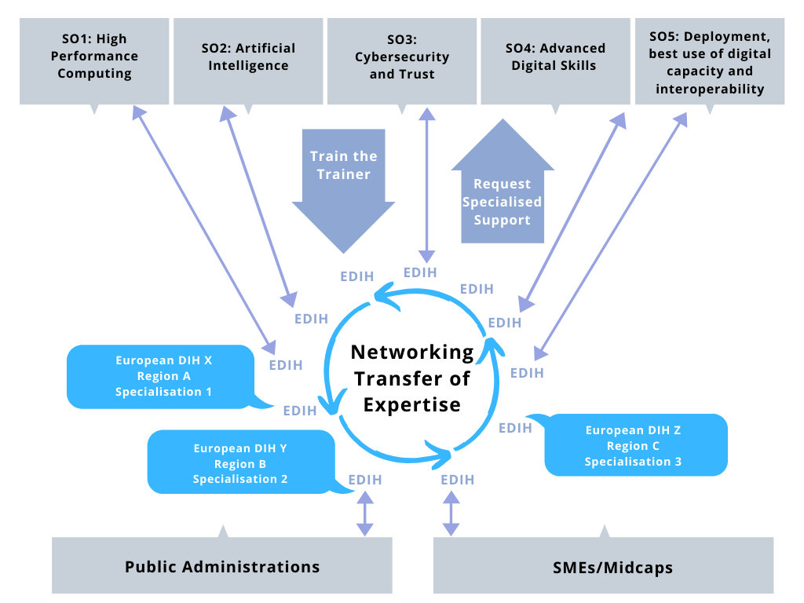
Figure 6. Schematic overview of the role of EDIHs in Digital Europe Programme. Networking will be animated by the “Digital Transformation Accelerator”

The Digital Transformation Accelerator is funded independently from the EDIH grants, through a procurement contract, and possibly could take the form of an “office” in Brussels. All legal entities that want to carry out this work are in principle eligible. At the moment, the following support activities are foreseen:

- Guidance for hubs: this may include guidance to set up new hubs, re-usable support tools (templates, webinars, guidelines, good practices, reusable capacities, etc.), carefully selected good practice cases, twinning programmes, etc.
- Manage and maintain an interactive catalogue of European Digital Innovation Hubs and other digital capacities funded in Digital Europe Programme.
- Train the trainer: developing ways to transfer the knowledge generated in the HPC, AI and Cybersecurity following the Specific Objectives to the EDIHs and vice versa, for instance by organising regular training workshops. This should allow EDIHs to diffuse this knowledge further to their own stakeholders, and ensure wide use of the capacities of Digital Europe (see also Section 1.3).
- Community building: this may include community building events between groups of EDIHs (geographical, similar focus, etc.), engaging with DIHs that are not part of the European DIH network). These activities should in particular set up links with DIHs focused on agriculture, health or public administration. See Annex 7 for more information about a declaration most MS signed on investments in digitalising agriculture.
- Matchmaking: this may include organising matchmaking events where needs for specific competences are advertised and matching hubs may be found. Such matchmaking should be supported by a digital matchmaking marketplace.
- Train the EDIHs about special financial instruments in InvestEU.
- Make available all information about short term training courses in advanced digital skills pillar of DEP, so that EDIHs can motivate their stakeholders to apply for these courses.
- Connect to initiatives like Start up Europe to help digital innovative companies/startups working with the EDIHs to scale up.
- Make available information about further funding mechanisms for SMEs in Horizon Europe.
- Putting the activities of the EDIH in the wider context of other relevant EC policies, and engagement with Regional and National policy makers.
- The Accelerator will also manage the media presence of the network, encouraging and coordinating the presence of EDIH on the web and on other media as needed.
- Impact assessment: this may include analysis of indicators and KPIs, developing targets, generating new knowledge to support benchmarking and policy recommendations.

These support activities should be carried out with close guidance from the EC officials responsible for the programme. The support activities will be essential for bringing together all parts of the Digital Europe Programme, and ensuring that the investments in the network of EDIHs will have the European added value that is expected.

Performance monitoring and KPI’s
All European Digital Innovation Hubs that receive a grant will be required to produce an activity report and a description of the extent to which they fulfil their KPI targets. Furthermore, there will be regular on-site reviews with external experts to monitor performance. MS can be involved in this process, by e.g. proposing external evaluators, being present during the review or read the reports.

As EDIHs have similar objectives regarding supporting SMEs and/or public sector administrations in their digital transformations, all hubs are requested to use a set of common KPIs. In addition, EDIHs could have additional KPIs that are specific to the particular characteristics and objectives of the hubs.

The mandatory KPIs are listed below:

Overall outputs
- Number of businesses and public sector entities, which have used the European Digital Innovation Hubs’ services, by user category (businesses of different sizes, public sector entities, etc.), sector, location and type of support received. The types of services covered by this indicator are:
- Information services (e.g. participation to events)
- "Test before invest" activities allowing beneficiaries to test technologies;
- Access to finance;
- Training activities;
- Networking activities;

- For "test before invest" services, further breakdowns for technology tested (AI, HPC or cybersecurity)", including whether Digital Europe capacities (HPC, AI, Cybersecurity, Advanced digital skills, Digital Service Infrastructure, …) were used.
- For access to finance: Amount of additional investments successfully triggered (e.g. through venture capital, bank loan, etc.)
- For collaboration:
- Nº of Collaborations with other EDIHs and stakeholders outside the region at EU level. Increase in %
- Nº of Infrastructures jointly shared / joint investments. Increase in %

Impact KPIs (achieved within the SMEs/public administration supported):
- Digital maturity evolution of the entities that have been supported by the European Digital Innovation Hubs.

Digital maturity will be defined on the basis of a questionnaire that asks an organisation how they are dealing with the following categories:
- INTELLIGENCE: Are intelligent systems used for decision making that understand and adjust to the specific circumstances? Are there systems that can predict and plan in a way that improve quality and optimise capacity?
- CONNECTIVITY: Is it possible to access data in a secure and real-time manner? Are systems and machines exchanging data, do they form an integrated part of the business processes?
- FLEXIBILITY: Is it possible to adapt and customise the systems and business processes to specific needs so that personalised products can be produced at mass-production prices?
- AUTOMATION : are repetitive tasks automated in a reliable way.
- SUSTAINABILITY Are natural resources used in a sustainable way, not wasting precious resources, and is no harm done to the environment and quality of life of the citizens?
- SERVICES Are new business models used where products are offered as a service?
- SOCIAL Are the workers motivated and engaged and can they carry out their work in an autonomous manner when working with the new systems?

- Through the Innovation Radar:
- the market maturity of innovations (“Market Maturity Indicator”);
- the market creation potential of any given innovation (“Market Creation Potential Indicator”)

Access to Digital Europe funds
This chapter explains in detail how the selection process and the grant agreements will be designed.

Grants
The draft regulation states that “Where European Digital Innovation Hub receives funding under this programme the funding shall be in the form of grants”.

The grant will cover the beneficiaries’ direct and indirect eligible costs. The latter is foreseen to be 7% of the direct costs.

The direct costs can cover procurement of hardware or software, depreciation of hardware or software, personnel costs of the EDIH for delivering digital transformation services to SMEs or public administrations (including subcontracting), and travel grants for hubs and local stakeholders to work with other hubs.

These costs must be estimated in the proposals, via a description of costs per activity and per beneficiary.

Once an activity has been reviewed and judged as successful (foreseen to happen once every 12 or 18 months through a review of the project), the actual costs made can be claimed and will be paid to the consortium after assessment. A suitable pre-financing mechanism will be foreseen so that the hub will be sufficiently resourced at the beginning of the grant.

In order to estimate the amount of state aid that will be passed on the SMEs, all proposals should also contain a price list for the services provided, representing the "value" of their services, and an estimation of how many customers will use these services. In the absence of market prices, this price list may be calculated on the efforts and investments and an according quantity structure. The price list would apply to all customers, but SMEs and public sector organisations would be able to use the services free of charge up to the upper Art 28 (4) limit of 200.000€ of the GBER. For follow up services or other services than mentioned in the price list, SMEs would have to pay a fee at market prices as well.

2-step selection process of the hubs
Section 2.5 explains that Member States define regional coverage and aim for complementarity of the specialisations of the hubs. The text below and Figure 7 explains how the EDIH network will be set up in the first years of the programme to reach approx. 130-260 hubs. The first step consists of designation of a list of hubs by the Member States. As a second step, all designated hubs will be invited to respond to a restricted call for proposals. If after this process there are still gaps in the coverage of the network of EDIHs, open calls may further complete the network. (Article 16 of the draft regulation: During the first year of the implementation of the Programme, an initial network of European Digital Innovation Hubs, consisting of at least one hub per Member State, shall be established. For the purpose of the establishment of the network, each Member State shall designate, in accordance with their national procedures, administrative and institutional structures candidate entities through an open and competitive process).

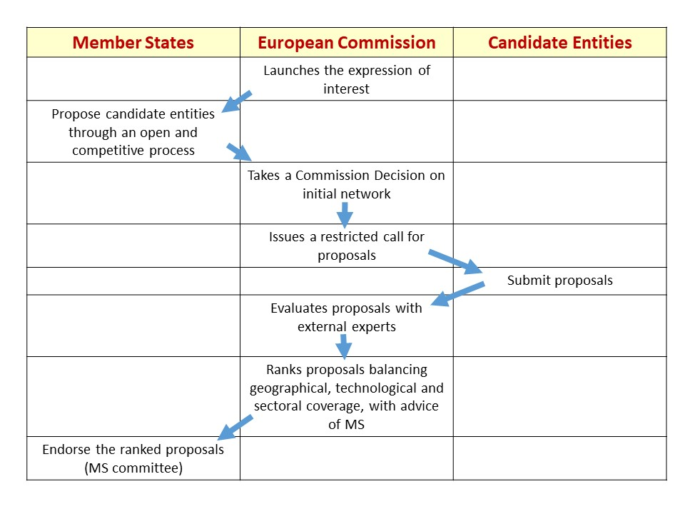
Figure 7: 2 step selection process of EDIHs

Expression of interest to Member States
All Member States are requested to designate a number of potential EDIHs geographically spread over the country, that respond to the demand of industry and public sector while taking into account existing assets of the country. They have to be selected through an open and competitive process in accordance with their national procedures, administrative and institutional structures. This process can have happened in the past, but not before 1 Jan 2015.
The draft Expression of Interest text is the following:
Member States are invited to designate a number of potential EDIH included between the minimum and maximum numbers mentioned in Table 1, but are free to designate more, even more than what could be funded in order to raise the competition during the restricted call process. The total amount of funding foreseen in the budget table for one country will be the maximum amount of co-funding foreseen in Digital Europe Programme for all EDIHs of that Member States during the duration of the Programme. It is allowed that several MS propose together “trans-national hubs”, serving neighbouring regions in different countries.
To be eligible, all designated entities should have:
- appropriate competences related to the functions of the European Digital Innovation Hubs defined above.
- appropriate management capacity, staff and infrastructure necessary to carry out the functions defined above;
- operational and legal means to apply the administrative, contractual and financial management rules laid down at Union level;
- appropriate financial viability, corresponding to the level of Union funds it will be called upon to manage and demonstrated, where appropriate, through guarantees, issued preferably by a public authority.

MS should provide the following information for the entities they propose:
- a short description about what the hub can do and which needs for the industry and areas of public interest can be addressed; its focus and geographical area;
- a description of the consortium forming the EDIH, its management capacity, staff and available infrastructure;
- the governance structure of the consortium.
- If the consortium plans to include further partners, which will be identified before the restricted call, a description of their role and type of organisation should be included.
- Information about the national strategy for the ideal coverage of EDIHs in that country and the maximum amount of co-funding available from the MS for each designated entity in accordance with the DEP and the Table 1.

In addition, all members of the consortium should be registered in the Participant Portal and have a PIC (Participant identification code) to comply to the operational and legal means to apply the administrative, contractual and financial management rules laid down at Union level.

Given the importance of Artificial Intelligence and its wide applicability in all sectors, we expect that at least one of the hubs selected in each country will be specialised in AI.

All received designated entities will be evaluated on their eligibility by the European Commission, and the Commission will adopt a Commission Decision under Article 16(3) DEP (examination procedure) listing the names of all eligible entities that will form part of the initial network.

Country | Population | EP seats 2019 | Projected budget (1000 €) | Min # of hubs | Max # of hubs (recommended) | NUTS 2 regions
Belgium | 11,351,727 | 21 | 26,809 | 4 | 8 | 11
Bulgaria | 7,101,859 | 17 | 21,702 | 3 | 6 | 6
Czech Republic | 10,578,820 | 21 | 26,809 | 4 | 8 | 8
Denmark | 5,748,769 | 14 | 17,872 | 3 | 5 | 5
Germany | 82,521,653 | 96 | 122,553 | 18 | 35 | 38
Estonia | 1,315,635 | 7 | 8,936 | 1 | 3 | 1
Ireland | 4,784,383 | 13 | 16,596 | 2 | 5 | 3
Greece | 10,768,193 | 21 | 26,809 | 4 | 8 | 13
Spain | 46,528,966 | 59 | 75,319 | 11 | 22 | 19
France | 66,989,083 | 79 | 100,851 | 14 | 29 | 27
Croatia | 4,154,213 | 12 | 15,319 | 2 | 4 | 2
Italy | 60,589,445 | 76 | 97,021 | 14 | 28 | 21
Cyprus | 854,802 | 6 | 7,66 | 1 | 2 | 1
Latvia | 1,950,116 | 8 | 10,213 | 1 | 3 | 1
Lithuania | 2,847,904 | 11 | 14,043 | 2 | 4 | 2
Luxembourg | 590,667 | 6 | 7,66 | 1 | 2 | 1
Hungary | 9,797,561 | 21 | 26,809 | 4 | 8 | 8
Malta | 460,297 | 6 | 7,66 | 1 | 2 | 1
Netherlands | 17,081,507 | 29 | 37,021 | 5 | 11 | 12
Austria | 8,772,865 | 19 | 24,255 | 3 | 7 | 9
Poland | 37,972,964 | 52 | 66,383 | 9 | 19 | 17
Portugal | 10,309,573 | 21 | 26,809 | 4 | 8 | 7
Romania | 19,644,350 | 33 | 42,128 | 6 | 12 | 8
Slovenia | 2,065,895 | 8 | 10,213 | 1 | 3 | 2
Slovakia | 5,435,343 | 14 | 17,872 | 3 | 5 | 4
Finland | 5,503,297 | 14 | 17,872 | 3 | 5 | 5
Sweden | 9,995,153 | 21 | 26,809 | 4 | 8 | 8
Total |  | 705 | 900 | 129 | 257 | 240

Table 1: Foreseen distribution of funding of Digital Europe Programme for EDIHs in all MS, based on the proposed budget by the Commission

Restricted Call by the European Commission
After the Commission decision on the initial network, the European Commission launches a restricted call for proposals to all the designated hubs listed in the initial network. The draft evaluation criteria are described in Section 3.3.

As soon as the designated hubs are known, they will be briefed on the restricted call process. They will be invited to networking events, and there will be electronic means to network with other hubs, for instance through the DIH Catalogue (it is proposed that the catalogue will have the functionality to see which hubs have been designated by Member States) and through the DIHNET Community Platform. This should allow DIHs to write quality proposals, to start collaboration with other hubs, and to propose relevant collaboration ideas already in their proposals. Such initial ideas can be extended during the project’s lifetime. For DEP funding, all designated hubs have to submit a proposal before a certain deadline.

The draft call text is the following:

Objective:
The first two years of the programme will see the setting up of an initial network of European DIHs and the early stages of the network’s expansion. The objective is to have at least one European DIH per Member State at the start of the network, with the aim of ultimately reaching all European regions, including the outermost regions, in subsequent years. Each DIH will have a specific focus/expertise, which could be strengthened over time and which should ensure the future strengths of the region’s industry and public sector, e.g. precision agriculture, smart manufacturing, smart government, a combination of AI, HPC or cybersecurity, and promising application areas. Each European DIH should have access to experimentation facilities (hardware and/or software) related to its specialisation to be used by companies and the public sector to test these technologies, including their environmental impact where relevant, before further investing in it.
The network of European DIHs will broaden the use of applications, technologies and services benefitting from AI, HPC and cybersecurity. In every country, there should be at least one EDIH specialised in AI.
The European DIHs will liaise, as appropriate, with the existing High Performance Computing and cybersecurity competence centres and the centres of excellence for AI to access the knowledge needed to provide the services in their remit to their customers. Through the “Digital Transformation Accelerator” ‘train-the-trainer’ events will be organised where the specialised centres will brief DIHs on the latest developments, while the latter provide user feedback.
Scope:
Upgrading of existing entities to the full functionalities of European Digital Innovation hubs, if needed by teaming up with other actors including from business and societal aspects in order to cover both the technology and business aspects that are needed to provide the complete set of services of an EDIH, including the necessary infrastructure, in a specific geographical area, covering the needs of the local SMEs and/or public sector organisations with respect to their digital transformation.
The proposals should describe:
- The geographical scope, sector(s) and application areas targeted, the technologies covered, etc, and how this responds to demand of SMEs and/or the public sector.

- How the EDIH will be set up and/or operated, and how it will build on ongoing activities and existing infrastructures, if appropriate. Explain the different activities to be carried out as a European Digital Innovation Hub. Explain your links with the local Enterprise Europe Network node, with the National Contact Point for R&I in your country, and if applicable with relevant sector specific networks and co-location nodes funded by the European Institute of Innovation & Technology.

- A price list for the services provided, representing the "value" of their services. In the absence of market prices, this price list may be calculated on the efforts and investments and an according quantity structure. The price list would apply to all customers, but SMEs and public sector organisations would be able to use the services free of charge up to the upper de minimis/Art 28 (4) limit of 200.000€ of the GBER. For highly individualised offers or solutions that directly support the SME’s business model, SMEs would have to pay a fee at market prices as well.

- How the proposal relates to other parts of the Digital Europe Programme, e.g. participation to “train the trainer” events to get trained by the competence / excellence centres of HPC, AI and cybersecurity or other capacities built up in the context of Digital Europe Programme; Planned collaboration mechanisms with other European Digital Innovation Hubs and a description of the specific services and competences offered to other hubs (not necessarily funded by Digital Europe Programme) in the EU and under what conditions.
- How the proposal is in line with main EU policy objectives, such as a Europe fit for the digital age, the European Green Deal, etc. If appropriate, the proposal should support national and/or regional policy objectives, relevant smart specialisation strategies, etc.
- Any regional, national or international activities which will be linked with the project, especially where the outputs from these will feed into the project.
- How the proposal triggers co-investments by Member States, regional authorities, and industry. Please note that EU investments in European Digital Innovation Hubs are dependent on the availability of an equal investment by Member States. Such co-financing is an eligibility criterion.
- How your proposal would support SMEs and public administrations in overcoming financial obstacles.
- Define your targets for the following KPIs:
- Number of businesses and public sector entities which have used the European Digital Innovation Hubs’ services, by user category (businesses of different sizes, public sector entities, etc.), sector, location and type of support received. The types of services covered by this indicator are:
- Information services (e.g. participation to events)
- "Test before invest" activities allowing beneficiaries to test technologies;
- Access to finance;
- Training activities;
- Networking activities;

- For "test before invest" services, further breakdowns for technology tested (AI, HPC or cybersecurity or other digital technologies), including whether Digital Europe capacities (HPC, AI, Cybersecurity, Advanced digital skills, Digital Service Infrastructure…) were used.
- For access to finance: Amount of additional investments successfully triggered (e.g. through venture capital, bank loan, etc.)
- For collaboration:
- Nº of Collaborations with other EDIHs and stakeholders outside the region at EU level. Increase in %
- Nº of Infrastructures jointly shared / joint investments. Increase in %

Type of actions
Grants with a co-funding of 50%
Budget
0,5 – 1 M€ per year per EDIH (this is the Commission contribution only)
Time of call
Open Q3 2020, close by 8 January 2021 (or as soon as possible after adoption of DEP)
Impact and KPI
- A balanced network of EDIHs covering most regions in Europe, addressing the needs of the public sector and many different industrial sectors, offering a wide range of specialised digital transformation services
- Increased digital maturity by organisations that have used the services of the EDIHs. Digital maturity will be defined on the basis of a questionnaire that asks an organisation how they are dealing with the following categories:
- INTELLIGENCE: Are intelligent systems used for decision making that understand and adjust to the specific circumstances? Are there systems that can predict and plan in a way that improve quality and optimise capacity?
- CONNECTIVITY: Is it possible to access data in a secure and real-time manner? Are systems and machines exchanging data, do they form an integrated part of the business processes?
- FLEXIBILITY: Is it possible to adapt and customise the systems and business processes to specific needs so that personalised products can be produced at mass-production prices?
- AUTOMATION : are repetitive tasks automated in a reliable way.
- SUSTAINABILITY Are natural resources used in a sustainable way, not wasting precious resources, and is no harm done to the environment and quality of life of the citizens?
- SERVICES Are new business models used where products are offered as a service?
- SOCIAL Are the workers motivated and engaged and can they carry out their work in an autonomous manner after the introduction of more digital ways of working?
- For innovations developed with the help of the EDIH, the following indicators from the Innovation Rader should be used:
- the market maturity of innovations (“Market Maturity Indicator”);
- the market creation potential of any given innovation (“Market Creation Potential Indicator”)

Evaluation process after the deadline
All proposals will be evaluated by an evaluation committee, comprising independent external experts, using the selection criteria described in Section 3.3. For the selection of evaluation experts the EC will consult the Member States.

After the technical evaluation of the proposals for a specific grant, a strategic assessment will follow where the European Commission taking into account advice of the Member States will rank all the proposals above threshold in a list based on score, geographical coverage and specialisation coverage. The European Commission will make the final selection for funding in the first year by taking from the ranked list the highest-ranking proposal from each Member State, taking into account the maximum amount of funding available. This procedure is repeated until all the budget is allocated or until all MS have reached their share. This should result in an initial network covering the needs of industry and areas of public interest with a comprehensive and balanced geographical coverage.

To allow to fund the greatest number of EDIHs in the first year, it is considered to use “multi-annual instalments”. This is a mechanism to fund longer term projects in slices of one year, each one drawing on the foreseen budget for that year.

Extending the initial network during year 2 and 3
For all those hubs that are part of the initial network, but that were not selected after evaluation in the first year, the current intention of the Commission is to offer a second possibility to (re-) submit the proposal for the grant during the second year. The Evaluation Committee, comprising also external evaluators will in the same manner as year 1 establish a ranked list of all proposals above threshold, and the Commission and the MS will select extensions of the network in the same manner as in the first year until the budget is depleted.

The first work programme of Digital Europe will cover the first two years, 2021-2022. For year 3 there will be another work programme. If the designation of the MS and the restricted calls did not result in a full coverage of the network and there are still gaps in the network, year 3 will launch an open and competitive process to fill the gaps to reach the final network, taking into account the share of (funding for) EDIHs per Member State. In this process, the eligibility and award criteria will be the same as for year 1.

Evaluation criteria used for restricted call
The Digital Europe Regulation stipulates that the award criteria shall be defined in the work programmes, and shall take into account at least the following elements:
- Maturity of the action in the project development;
- Soundness of the implementation plan proposed;
- The need to overcome financial obstacles such as the lack of market finance.

The following elements shall be taken into account where applicable:

- the stimulating effect of Union support on public and private investment;
- the expected economic, social, climate and environmental impact;
- accessibility and ease of access to respective services;
- a trans-European dimension;
- a balanced geographical distribution across the Union including bridging geographical digital divide, including the outermost regions;
- the presence of a long-term sustainability plan;
- the freedom for re-use and adaptation of the projects' results;
- synergy and complementarity with other Union programmes.

The proposal is to use similar award criteria as in the CEF programme, and arrange the different evaluation elements under three criteria: ‘Relevance’, ‘Implementation’ and ‘Impact’, further described below. Note that these draft criteria are meant to be used throughout the whole Digital Europe Programme, and not only for the European Digital Innovation Hubs.
Relevance
- Alignment with the objectives and activities as described in the Work Programme and in the call for proposals
- Contribution to long-term policy objectives, relevant policies and strategies, and synergies with activities at European and national level
- Extent to which the proposal can overcome financial obstacles such as the lack of market finance

Implementation

- Maturity of the proposed action and efficient use of resources
- Soundness of the implementation plan
- Capacity of the applicants, and when applicable the consortium as a whole, to carry out the proposed work and mobilise the necessary resources

Impact

- Extent to which the proposal will achieve the expected impacts listed in the Work Programme
- Extent to which the proposal will strengthen competitiveness and bring important benefits for society
- Extent to which the proposal demonstrates environmental sensitivity, including for climate change issues (e.g. through sustainable use of resources and/or contribution to circular economy/ green communication to the public)

What is expected of the proposal?

Following the evaluation criteria, the proposal template will include three corresponding sections, named Relevance, Implementation and Impact. For each of the following sections we describe first in general terms what is expected in a proposal, followed by specific expectations regarding European Digital Innovation Hubs. These are marked by a yellow exclamation mark.

Section Relevance
- Describe the overall and specific objectives of the project, which should be clear, measurable, realistic and achievable within the duration of the project. Objectives should be consistent with the expected impact of the project (see section Impact). Key performance indicators should be defined for various stages of the project.
- Indicate how your proposal is aligned with the objectives and activities as described in the Work Programme and in the call for proposals.
- Describe and explain the overall concept underpinning the project.
- Describe and explain the overall approach, distinguishing, as appropriate, activities indicated in the relevant section of the work programme.
- Describe the contribution of your proposal to long-term EU policy objectives, other relevant policies and strategies, and synergies with activities at European and national level.
- Describe how the proposal can overcome financial obstacles such as the lack of market finance

- Explain your focus as a European Digital Innovation Hub, e.g. the geographical scope, sector(s) and application areas you target, the technologies you cover, etc, and how this responds to demand of SMEs and/or the public sector.
- Explain how you will set up and/or operate a European Digital Innovation Hub. Explain how you will build on ongoing activities and existing infrastructures, if appropriate. Explain the different activities you will carry out as a European Digital Innovation Hub.
- Explain the services and competences you can offer to other hubs in the EU and under what conditions, such as test before invest; skills and training; support to find investments; innovation ecosystem and networking opportunities. Define your KPI’s and targets.
- Explain how your proposal relates to other parts of the Digital Europe Programme, e.g. planned collaboration mechanisms with other European Digital Innovation Hubs and the competence / excellence centres of HPC, AI and cybersecurity or other capacities built up in the context of Digital Europe Programme.
- Your proposal should be in line with main EU policy objectives, such as a Europe fit for the digital age, the European Green Deal, etc. Your proposal should support national and/or regional policy objectives, relevant smart specialisation strategies, etc.
- Describe any regional, national or international activities which will be linked with the project, especially where the outputs from these will feed into the project.
- Describe and explain how your proposal triggers co-investments by Member States, regional authorities, and private sector. Please note that EU investments in European Digital Innovation Hubs are dependent on a minimally equal investment by Member States. Such co-financing is an eligibility criterion.
- Describe and explain how your proposal would support SMEs and public administrations in overcoming financial obstacles.

Section Implementation
For this section of the proposal the following elements are expected:
- A brief presentation of the overall structure of the work plan;
- Timing of the different work packages and their components (Gantt chart or similar) and a graphical presentation of the components showing how they inter-relate (Pert chart or similar);
- Detailed work description, i.e.:
- a list of work packages;
- a description of each work package;
- a list of major deliverables;
- a list of milestones;
- a table with critical risks identified and mitigating actions;
- Use of resources:
- A table showing planned investments in hardware and software
- A table showing number of person months required;
- An explanation of subcontracting costs for involvement of subcontractors
- A table showing ‘other direct costs’ for participants where those costs exceed 15% of the personnel costs
- Define the services offered and their associated price; this will constitute the price list necessary for determining the amount of aid passed on SMEs
- Describe the proposed management structures and procedures; risk and innovation management.
- Describe the consortium. Indicate how the consortium matches the project’s objectives, and how it brings together the necessary expertise. Indicate how consortium members complement one another, how each member contributes to the project, and show that each has a valid role.
- Describe the capacity of the applicants, and when applicable the consortium as a whole, to carry out the proposed work and mobilise the necessary resources.
Definitions:
‘Work package’ means a major sub-division of the proposed project.
‘Deliverable’ means a distinct output of the project, meaningful in terms of the project's overall objectives and constituted by a report, a document, a technical diagram, a software etc.
‘Milestones’ means control points in the project that help to chart progress. Milestones may correspond to the completion of a key deliverable, allowing the next phase of the work to begin. They may also be needed at intermediary points so that, if problems have arisen, corrective measures can be taken. A milestone may be a critical decision point in the project where, for example, the consortium must decide which of several technologies to adopt for further development.

Section Impact
- Describe how your project will contribute to each of the expected impacts mentioned in the work programme, under the relevant topic. Describe the proposed measures to achieve the expected impacts and show how those measures will help to achieve the expected impacts. Include sufficient communication and outreach measures.
- Describe how the proposal will strengthen competitiveness and bring important benefits for society
- Describe the extent to which your proposal demonstrates environmental sensitivity, including for climate change issues (e.g. through sustainable use of resources and/or contribution to circular economy/ green communication to the public)
- Describe any barriers/obstacles (such as regulation, standards, public acceptance, workforce considerations, financing of follow-up steps, cooperation with other organisations), that may determine whether and to what extent the expected impacts will be achieved. (This should not include any risk factors concerning implementation).
- Provide an ‘impact and communication plan’ that is regularly updated along the duration of your project. Describe the proposed communication and outreach measures for promoting your European Digital Innovation Hub, its services, and its results during the period of the grant. The plan should be proportionate to the scale of the project, and should contain measures to be implemented during and after the end of the project, if applicable.
- Define the short, medium and long-term effects of the project.
- Who are the target groups? How will the target groups benefit concretely from the project and what would change for them? How will you actively reach out to them and engage them in the activities?
- Does the project aim to trigger change/innovation? If so, describe them and the degree of ambition (progress beyond the status quo)
- Explain how your EDIH will contribute to achieving a well-functioning network of European Digital Innovation Hubs.
- How will you involve start-ups and SME suppliers and if relevant artists/creatives to respond to the needs of the target groups?
- How will you involve investors to create impact?
- Wherever possible, use the indicators mentioned in the workprogramme and define your targets.
- Communication and outreach measures should be tailored to the needs of different target audiences, including groups beyond the project's own community.
- Please explain how you will deal with Intellectual Property that is generated via your services, possibly together with other EDIHs, SMEs, public authorities, etc.
- Please describe how your proposal would address issues related to the environment or climate change. Please indicate how your proposal would balance environmental issues and competitiveness and growth objectives.

Conclusions: European added value for supporting hubs in Digital Europe
Through the co-investments in hubs by Member States and Digital Europe Programme important synergies between the two sources of investment will be reached, as summarised in Figure 7. Apart from the advantages provided in Figure 7, investing in hubs at EU level will also contribute to completing the Digital Single Market; hubs can help implement interoperability, standards, and EU-wide digital administrative solutions that create a business-friendly environment for SMEs to easily access new markets.

Innovations in one country often build on knowledge that was created elsewhere. The network of European Digital Innovation Hubs promote knowledge diffusion and technology spill-over. The expected knowledge spill-overs between advanced and less advanced countries will be a strong force underlying cross-country convergence, benefitting both sides, and creating a stronger Single Market as a recent study showed, and reducing the digital divide.

Furthermore, EU investments will be a leverage factor to upscale and network EDIHs and provide a meaningful contribution to the current gap in private investment in digitalisation. Digital Europe Programme will also allow Member States, Regions and the EU to co-invest jointly in the same hubs, thus stimulating pooling of resources.

Local added value | European added value
Hub will improve competitiveness of local economy by stimulating digital transformation | Hubs will improve their offer by acquiring new knowledge and capacities through their participation in Digital Europe on HPC, AI, Cybersecurity, Advanced digital skills and public sector solutions
Hub has specialisation which is based on local strengths and addresses local needs | Networking of the hubs will stimulate knowledge transfer between hubs and rationalisation of investments because facilities are opened up for use outside the local boundaries. It reduces duplication and optimises investments in infrastructure
Hub is near their customers and they speak the same language | Hubs will learn from other hubs by sharing best practices, and by collaboration of hubs in case of missing expertise/facilities.
 | The hub network will be a means to promote excellence developed locally to other regions in Europe; it will open new markets for the companies involved in the innovations
Figure 8. Added value of combining local and European investments

Annex - The current landscape of Digital Innovation Hubs

Innovation experiments in Horizon 2020
The Digitising European Industry Strategy identified Digital Innovation Hubs (DIHs) as a key mechanism to help the digital transformation of companies. Between 2016 and 2020 the EU is investing €100 million per year, through H2020, to support DIHs across Europe that help SMEs and mid-caps go digital. Through initiatives such as ICT Innovation for Manufacturing SMES (I4MS) and Smart Anything Everywhere (SAE), more than 150 DIHs and 500 Start-ups, SMEs and mid-caps have taken part so far in 370 different innovation experiments where companies tested digital innovations in collaboration with DIHs.

By 2020, approximately 2000 innovative SMEs across Europe will have received this kind of support from the EU. As a result of this EU funding technically tested prototypes, replicable experiments, solutions and significant experience have been generated that DIHs could benefit from. This provides a solid basis for further developing the network of DIHs.

Digital Innovation Hubs across the EU
As part of their digitisation strategies, around 15 Member States are implementing national DIH strategies, e.g. Mittelstand 4.0 in Germany, Smart Industry Field Labs in the Netherlands, or the Italian Piano Nazionale Industria 4.0. The starting point, structure and focus of the DIHs vary across the EU; depending on the national or regional strengths, identified in the respective Smart Specialisation Strategies, or national/regional digitisation initiatives.

Despite the diverse nature of DIHs, a DIH catalogue – "yellow pages" – was put in place and monitors the development of DIHs across Europe. Following a bottom-up approach, organisations that comply with a set of basic criteria, may feature in this catalogue. The purpose of the catalogue is to support community building. Organisations registered in the catalogue will be invited to stakeholder meetings. Being in the catalogue is never a pre-requisite for funding.

Covering white spots and expanding the network
The EU aims to ensure that all companies would have a DIH at working distance; our objective is to have at least one DIH (as a proxy), in every region by 2020. There are however, still many white spots across the EU, especially in Central and Eastern Europe. To bridge this gap, the EU is supporting the creation of new DIHs in those regions through several actions. The project ‘Smart Factories in new EU Member States’ provided training to 34 potential DIHs in the EU13. The current ‘DIHELP’ project is helping another 30 DIHs from 17 countries in regions across Europe that do not have a digitalisation programme yet and where private sector capacity needs to be improved. In addition, a call of €8 million of the Horizon 2020 programme both in 2019 and in 2020 respectively, will support DIHs and SMEs in regions so far underrepresented. The various networking and collaboration activities also help DIHs from these regions to engage with other DIHs by actively participating in the different DIH workshops, networks of the different Coordination and Support Actions (CSAs) and the recently launched DIHNET Community platform.

Annex - Seamless collaboration between Enterprise Europe Network and European Digital Innovation Hubs

Introduction to Enterprise Europe Network

Just like EDIHs, the Enterprise Europe Network (EEN) is the world’s largest support network for small and medium sized enterprises. At the end of 2018, the Enterprise Europe Network covered 65 countries with 604 partner organisations of which 69 are Business Cooperation Centres grouped in 29 third countries as shown in Figure 9 below.

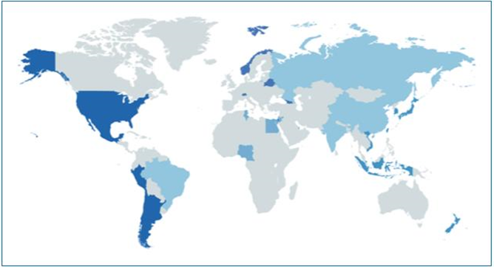
Figure 9 Business Cooperation Centers of the Enterprise Europe Network
The partner organisations of the EEN are genuine business & innovation support organisations (eg. chambers of crafts, chambers of industry and commerce, regional development agencies, innovation agencies, research organisations, universities, regional/national promotional banks) that were selected following a competitive call for proposals. The EEN partners are organised in consortia covering at least a NUTS-2 region.

The EU consortia receive co-funding from the EU budget (up to 60% of all their eligible costs) and the non-EU consortia finance their participation in the Network on a self-financing mode.
The general target group of the EEN are SMEs with a potential for international growth. Beyond that, the EEN also target its services at distinct target groups composed of the beneficiaries of the EIC pilot that can be at the same time innovative start-ups and scale-ups. Being embedded in their regional/national business and innovation support ecosystems, the EEN teams offer their services also to other ecosystem actors such as clusters, research and technology organisations, and universities.
The services of the EEN are available to the SMEs at the level of their regional/national EEN-consortium. These services are grouped in 3 categories; business advisory services, partnership services and innovation services as shown in Figure 10 below.
Within the business advisory services, SMEs can receive:
- free advice on regulatory compliance with EU legislation
- free market intelligence in order to support the preparation of internationalisation activities
- free consultation on access to finance regardless where the source of funding is located (eg. whether it is an EU-funding scheme or a national/regional funding possibility including also the funding possibilities offered by the ERDF-backed measures)
- free basic consultation on issues related to intellectual property

SMEs can also voice their experience – be it bad or good – with EU legislation so as to facilitate evidence based policy making for the European Commission.

Within the international partnership services, SMEs can receive:

- free partnering services to foster the set-up of consortia applying for Horizon 2020/Horizon Europe calls
- free partnering services which include the use of the Partnership Opportunity Database (IT-supported database for partnership offers and partnership requests with automated matching) and the participation in specific B2B matchmaking events with pre-arranged meetings with potential new business partners
- The matching services are also offered in relation to find potential investors/financers for (B2F) for SMEs with an innovative idea including their pitching preparations
- SMEs can also participate in company missions in order to establish new business partnerships

Within the innovation services, SMEs can benefit from:
- free support for technology transfer by helping the valorisation of research results into commercial applications and new products and services
- free innovation management capacity building services which help SME managers to be able to capture all innovation possibilities and carry out complex innovation projects and anchor innovation culture in the day-to-day operation of their business. With a specific diagnosis tool, the EEN also scans all the digitisation potential of SMEs and helps to establish a concrete action plan to implement to proposed recommendations.
- SME beneficiaries of the enhanced European Innovation Council (EIC) pilot can receive free Key Account Manager services of the EEN which consists of a thorough needs analysis for the smooth implementation of the awarded innovation project. Hereafter the Key Account Manager facilitates the identification of the best suitable coach for the most needed skill.

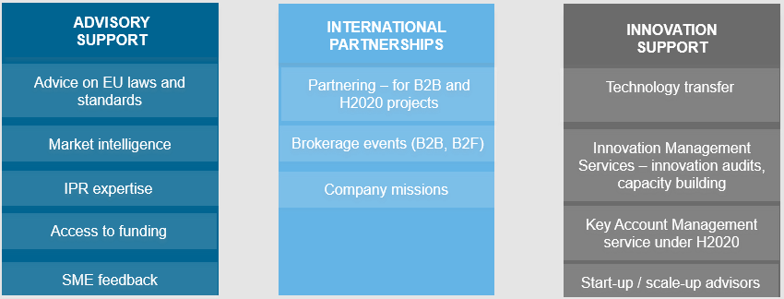
Figure 10. : Services of the Enterprise Europe Network consortia

Foreseen co-operation between the two networks
Cooperation offers a win-win situation by reinforcing the synergetic service offerings of the two networks. As for the form of cooperation, EDIHs and EEN nodes that are operating in the same territory could conclude a service-level cooperation which clearly describes how the two will complement each other and will work synergistically together, offering a seamless service to SMEs. This will also avoid the problem of double funding the same activities through different projects. Possibilities are:

- Joint investor related events
- EEN partners often have longstanding business relations with investors, some EEN partners are even promotional banks managing financial instruments funded by the ERDF operational programmes, which can be of benefit to organise joint investor related events. Beyond that, EEN partners also have experience in preparing SMEs for their pitching in front of an investor panel.
- Organisation of common trainings/workshops/info-days for SMEs
- EEN partners can (co)organise trainings for SMEs together with EDIHs.
- Referrals of SMEs (from EEN to EDIHs and from EDIHs to EEN)
- EEN partners can enhance the SME outreach of the EDIHs and can refer SMEs to the regional/national members of the EDIH network.
- EEN partners can also match businesses with EDIHs in a cross-border context.
- Equally, for further specialised services such as internationalisation the EDIHs can also signpost businesses to EEN partners.
- Digital scans/audits/assessments
- EEN partners carry out digital audits (basic assessment of digital transformation potentials) with the Digital Innovation Quotient tool of the IMP3ROVE Academy – the action plan as a result of the digital audit should include EDIH service offerings whenever appropriate.
- Audits could also be carried out by joint teams of local/regional EDIHs and EEN partners.

This will be further facilitated by common activities (organised jointly by DG GROW and CNECT or their support actions).

Annex – Declaration of cooperation on smart and sustainable digital future for European agriculture and rural areas on Agriculture
The Declaration of cooperation on smart and sustainable digital future for European agriculture and rural areas was launched at Digital Day 2019 and signed by the following EU countries: Austria, Belgium, Bulgaria, Czechia, Germany, Estonia, Ireland, Greece, Spain, France, Italy, Cyprus, Latvia, Lithuania, Luxembourg, Hungary, the Netherlands, Poland, Portugal, Romania, Slovenia, Slowakia, Finland, Sweden, the United Kingdom. The full declaration is available at https://ec.europa.eu/digital-single-market/en/news/eu-member-states-join-forces-digitalisation-european-agriculture-and-rural-areas .
The passages relevant for European Digital Innovation Hubs are:
- (...)
- build on ongoing initiatives such as the SmartAgriHubs network and ensure that agriculture is covered as an area of expertise in at least one digital innovation hub in each Member State, which could be a dedicated agri-food digital innovation hub or a more general one;
- develop a network linking the dedicated agri-food digital innovation hubs making cutting-edge digital technologies and specialised services for agriculture available for local farming and food production ecosystems, including small-scale farms, throughout Europe;
- close the loop by enabling cooperation between the network of dedicated agri-food digital innovation hubs and the more general network of digital innovation hubs;
All these actions are eligible under the European Digital Innovation Hubs scheme of Digital Europe Programme, but they can also be funded by other sources. Also in those cases, Digital Europe Programme foresees mechanisms to ensure that such DIHs operating in the field of agri-food may participate to networking activities foreseen in Digital Europe Programme (see Section 2.6).

The European Green Deal, COM(2019) 640
Digital Europe Programme has the following definition: ‘European Digital Innovation Hub' means legal entity selected in accordance with Article 16 in order to fulfil the tasks under the Programme, in particular providing directly, or ensuring access to, technological expertise and experimentation facilities, such as equipment and software tools to enable the digital transformation of the industry, as well as facilitating access to finance. European Digital Innovation Hub shall be open to business of all forms and sizes, in particular to SMEs, midcaps, scale-ups and public administrations across the Union;
The beneficiaries should declare that for the activities covered by the grant they apply a not-for-profit objective, i.e. all money earned by them or donated to them is used in pursuing the EDIH’s objectives and keeping it running.
The InvestEU Advisory hub is foreseen to become part of the future InvestEU programme (see Section 1.6)
The Enterprise Europe Network helps businesses innovate and grow on an international scale. It is the world’s largest support network for small and medium-sized enterprises (SMEs) with international ambitions. (https://een.ec.europa.eu)
RTOs are public or private organisations that provide a range of research, development and technology services, principally to business and governments
https://ec.europa.eu/cefdigital/wiki/display/EHOPERATIONS/eHealth+DSI+Operations+Home
https://ec.europa.eu/digital-single-market/en/news/ministerial-declaration-egovernment-tallinn-declaration
https://ec.europa.eu/regional_policy/en/policy/cooperation/european-territorial/egtc/
https://s3platform.jrc.ec.europa.eu/thematic-platforms
https://s3vanguardinitiative.eu/
See Section 2.2 for the co-investment principles for EDIHs.
The EU outermost regions are exempt from this rule.
Some countries are investing in innovation voucher schemes for SMEs. These cannot count for the 50% co-funding of MS, because there would be a risk that the EDIHs are double funded in the context of State aid. Of course countries can still have innovation voucher schemes, but services delivered by the EDIHs in the context of the grant of Digital Europe Programme cannot be funded through innovation vouchers, since they have already been subsidised through the grant.
“Local” should not be interpreted in a narrow geographical sense. What is meant is the “natural” scope of the EDIH.
The draft regulation mentions: “The European Digital Innovation Hubs should develop appropriate synergies with Digital Innovation Hubs funded by Horizon Europe or other R&I programmes, the European Institute of Innovation and Technology, in particular the EIT Digital and also with established networks such as the European Entreprise Network or the EU Invest hubs”
the JRC’s Innovation Radar methodology (already deployed in Digital and non-digital themes of Horizon 2020, EIC Pilot as well as in DG ENV’s LIFE programme) will be used to assess the impact of “Test before invest” and “Support to find investments” services of EDIHs.
Member States are free to determine the ideal deployment and sizes of the national EDIH network. This approach can vary among MS and it is essential for the European Commission to know about the national strategy to stay in line with it. There are MS, which could support a relatively small number of EDIHs with branch offices in regions. Other MS would prefer to spread the EDIHs evenly across their country. This deployment depend on national strategies and EC want to support them, assuming that it is not in conflict with the goal of DEP.
Note that the €200.000 limit can apply to different schemes developed by the public authorities (and not only to EDIH activities)
the JRC’s Innovation Radar methodology (already deployed in Digital and non-digital themes of Horizon 2020, EIC Pilot as well as in DG ENV’s LIFE programme) will be used to assess the impact of “Test before invest” and “Support to find investments” services of EDIHs.
The initial network will be evenly spread over all MS, according to their foreseen ratio of EDIHs, and with a minimum of 1 EDIH per MS.
The term ‘project’ used in this template equates to the activities carried out to set up and/or operate a EDIH, and which are covered by the requested grant.
https://www.bertelsmann-stiftung.de/en/topics/latest-news/2019/may/eu-single-market-boosts-per-capita-incomes-by-almost-1000-euros-a-year/
SmartAgriHubs - Connecting the dots to unleash the innovation potential for digital transformation of the European agri-food sector (https://cordis.europa.eu/proiect/rcn/218572/factsheet/en)

