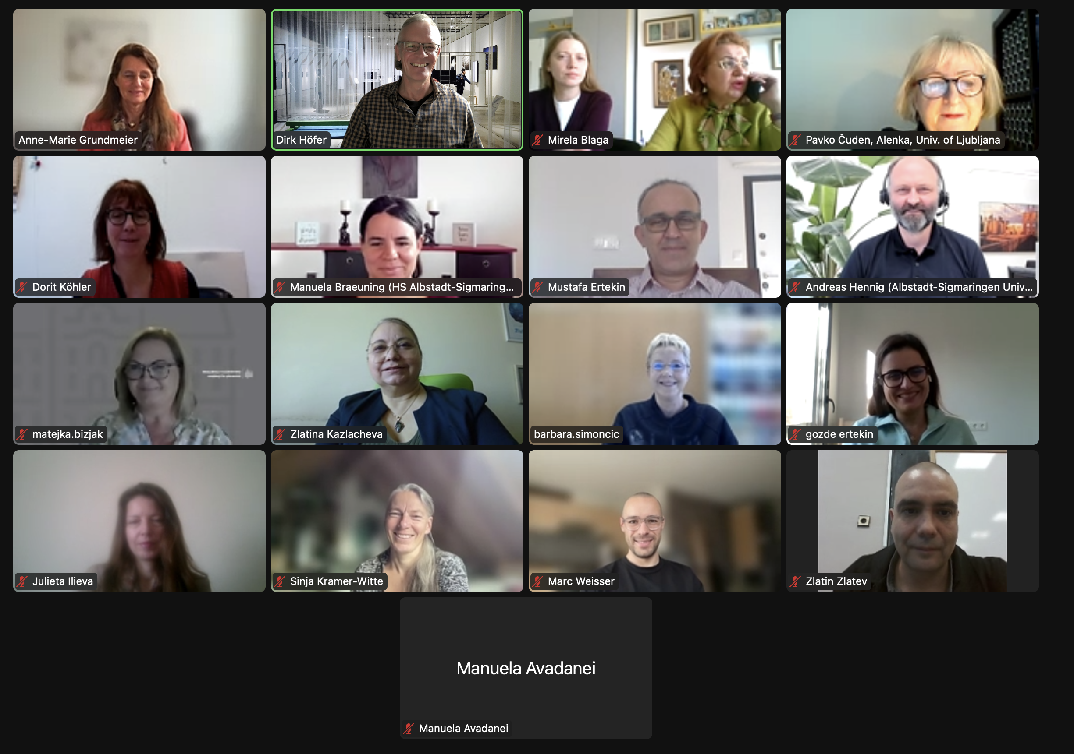

Figure 1: Screenshot of the TexUnite kick-off-meeting with participants from all partner universities

Kicking-off the European Project TexUnite

On 25 October 2024, the European research project 'TexUnite - Service Learning on Sustainability in Textile and Fashion Education' was launched with an online kick-off meeting. The international project aims to enhance key competences necessary to achieve sustainability goals by integrating service learning with virtual exchange in textile and fashion education. The project represents the first international study programme with service learning components in the textile and fashion sector in Europe. By implementing service learning in project-based seminars with partner organisations such as NGOs, communities or sustainability-oriented companies, the initiative promotes environmental and social engagement in higher education. The aim is to give students the opportunity to engage in social and sustainable activities as part of their academic learning and to see what they can contribute. As a pedagogical strategy, service-learning enables students to cultivate sustainability-oriented knowledge and attitudes while serving the community, providing them with an active learning experience. All activities are in line with European approaches to sustainability in the textile and fashion industry.

Within TexUnite, the University of Education Freiburg is cooperating with the Hochschule Albstadt-Sigmaringen in Germany and universities from four different countries - George Asachi Technical University of Iaşi in Romania, the University of Ljubljana in Slovenia, Trakia University of Stara Zagora in Bulgaria and Ege University in Izmir, Turkey. Over the next three years, the project will be co-funded by the European Union's Erasmus+ programme, one of Europe's most successful initiatives, which is also of great importance for higher education programmes.

The coordinator, Prof Dr Anne-Marie Grundmeier (Pädagogische Hochschule Freiburg), welcomed the participants and explained the history of the project (Figure 1). After giving an overview of the main objectives of the project, she informed about the first administrative steps, timeframes for the work packages and deadlines, so that everyone had a clear idea of the structure of the TexUnite project. Next, Ms Grassler, EU Officer of the Universities of Education in Baden-Württemberg, informed about the current orientation of the Erasmus+ programme with a focus on content and quality. She gave many helpful hints and tips on proper financial and administrative project management. The third party funding department of the Pädagogische Hochschule Freiburg continued with the legal aspects necessary for the consortium to become operational quickly.

The team enjoyed a virtual coffee break during which each partner university presented at least one typical pre-Christmas pastry from their country. After the break, the main activities within the work packages and the responsibilities of the partner universities were discussed and confirmed. The team decided on a clear dissemination strategy to achieve the required project objectives, including a social media presence (Figure 2). Finally, the next project steps and deadlines were discussed.

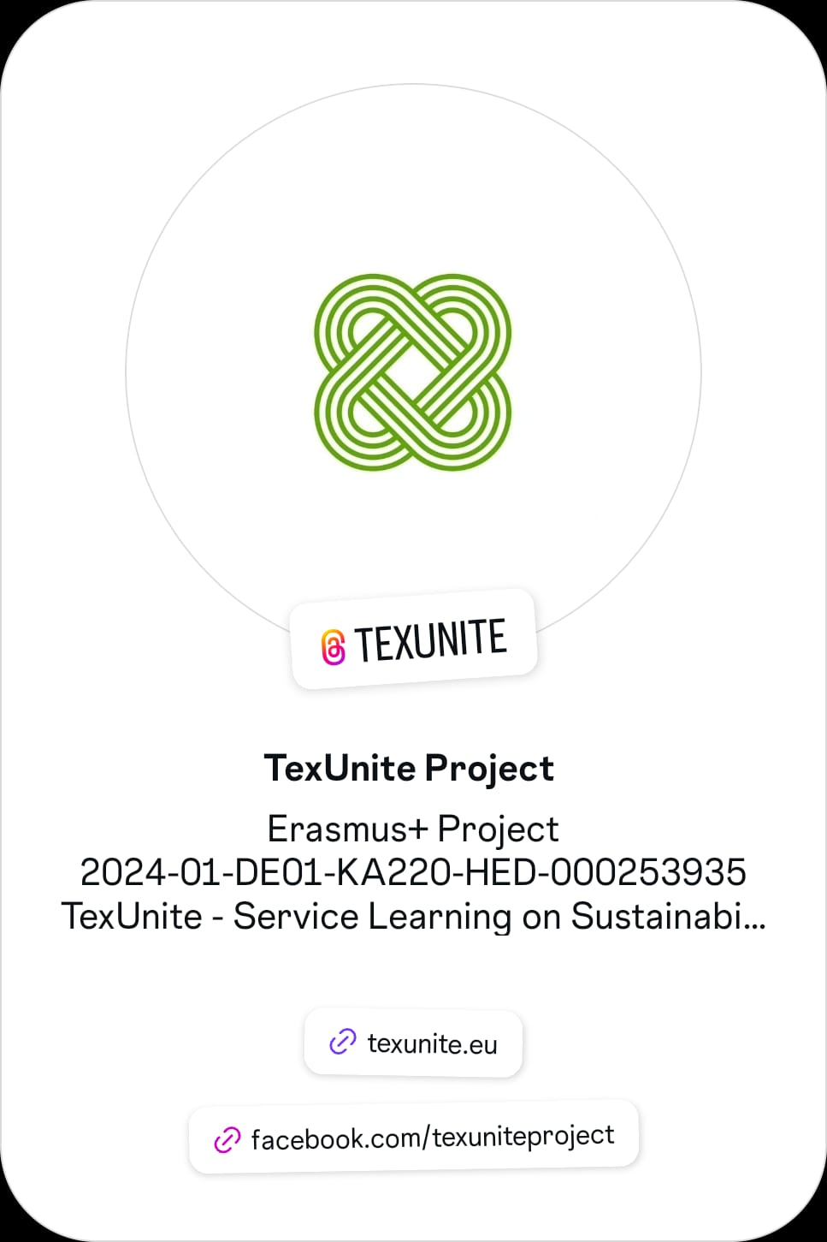

***If you are interested in sustainability issues related to textiles and fashion and the educational approach of service learning, explore our website and follow us on social media.***

***TexUnite Consortium***

Figure 2: Screenshot of the TexUnite Facebook and Instagram account

Over the next three years, the TexUnite project will produce research-based comprehensive teaching and learning materials and best practice examples of service-learning projects. Firstly, the Sustainable Textile Lab, an online further education seminar with digitally enhanced teaching and learning arrangements, will be developed and implemented to run sustainability-focused project seminars. University teachers and their student teams will engage in intercultural exchange using the Virtual Exchange method. In this way, service-learning projects will be carried out in international tandems and evaluated at each partner university. Local stakeholders, such as NGOs, communities or sustainability-oriented companies, will be involved in each project. By linking digitisation with sustainability, the aim is to share the project results on Open Educational Resource (OER) platforms.

These steps pursue the main objective of integrating service learning into textile and fashion education to promote democratic values, awareness and sustainability, and the third mission of universities to promote integration with their environment - society, communities and the economy.

TexUnite consortium, November 2024