Figure 1. Screenshot of the Second TexUnite Transnational Partner Meeting

Second TexUnite Transnational Project Meeting

The second TexUnite Transnational Project Meeting (TPM) was held online and hosted by Trakia University, Bulgaria, on April 11 2025 (Figure 1). Prof. Dr. Zlatina Kazlacheva, the leader of the Trakia University team, opened the meeting with a warm welcome to the participants.

At the beginning of the meeting, Prof. Dr. Anne-Marie Grundmeier, the coordinator of the TexUnite project, reported on the strategy paper Dissemination Strategy. Apl. Prof. Dr. Dirk Höfer presented the 2025_April Dissemination List. The consortium members provided input on planned entries for upcoming dissemination activities.

The meeting continued with the preliminary results of the expert interviews. Prof. Höfer presented a detailed PowerPoint presentation with the first results of the expert interviews. He presented the methodological procedure for the expert interviews, i.e. the preparation, conduct and transcription of the interviews. Based on a five-step general scheme for qualitative content analysis, Prof. Höfer turned to the topic of qualitative data analysis. The deductive-inductive coding was carried out using the qualitative data analysis software MAXQDA. The codes allowed the identification of central themes, patterns and differences in the participants' responses. The coded statements for all three country-specific interviews were summarised by the interviewer and transferred to a codebook table. Prof. Höfer and Prof. Grundmeier applied an extended comparative analysis provided by MAXQDA (Figure 2). The country-specific perspectives were compared with the comparative results of the codebook table. They were presented in an overview, including the potential for the implementation of EU sustainability regulations, followed by a comparison of the codebook table and the country-specific summaries.

Figure 2. Preliminary results of expert interviews based on **an** analysis provided by MAXQUDA

Prof. Grundmeier reported on the strategy paper Management and Management Risk Plan, and Prof. Höfer presented a file called the Logical Framework, a project cycle management method for cooperation projects, which is fundamental for the implementation of donor-funded grants. The file provides information and an overview and thus represents an orientation framework to support all members in their activities.

The meeting continued with the continuation of the SusTexLab: How to integrate service learning into curricula. Prof. Dr. Anne-Marie Grundmeier explained the concept of SL in the context of sustainability, particularly in the fashion and textile industry. Her presentation highlighted the benefits of involving students in projects that address environmental issues, promote practical experience, encourage innovation and creativity, raise ethical awareness, develop interdisciplinary skills, encourage community involvement and prepare responsible professionals. The historical development of service learning, its characteristics, and its benefits were explained, including the development of 21st century skills, civic responsibility, and deeper learning. The importance of stakeholder involvement and the need for a structured project plan were discussed. The role of universities in social development and innovation was also highlighted, as was the potential of SL to enhance learning processes and engage students. Prof. Grundmeier turned to the topic of SL in textile and fashion education, where SL should provide practical experience, raise ethical awareness and build interdisciplinary skills. The consortium members discussed the challenges and opportunities of integrating SL into their courses.

The agenda continued with the presentation of SL pilot projects and discussion. Nadine Kitzlinger presented on the SL project Future Fashion Walk in Freiburg (Figure 3), which will be part of her seminar on fashion and the fashion market at PHFR. The project aims to raise students' awareness of sustainable fashion consumption and to involve them in the development of a Future Fashion Walk in Freiburg. It combines theoretical learning with practical encounters and critical engagement with real challenges in the fashion sector and will focus on the social and environmental impacts of fast and ultra-fast fashion and sustainable alternatives. Students will work in teams to research and investigate sustainable fashion options in Freiburg with the aim of creating a comprehensive collection. The project will end with a future fashion walk through Freiburg, where students will present the shops they have researched. The project will also include a virtual exchange (VE) with the UoL project.

Prof. Dr. Matejka Bizjak presented her corresponding SL project at the University of Ljubljana. Her SL project Sustainable Fashion Walk will be a part of the elective course Clothing Technology Support. The project involves students visiting second-hand shops, boutiques, and workshops dealing with sustainable concepts and creating a map for a sustainable fashion walk in Ljubljana. It is expected to raise awareness of sustainability and promote sustainable behaviour. The organisation of the VE between the participants of both courses was discussed.

Prof. Manuela Bräuning presented on the SL project Expansion of an Inclusive Production of Jerseys together with the non-profit associated partner Wasni. Wasni specialises in the production of hoodies and employs people with disabilities. The students are tasked with increasing sales, redesigning the hoodie configurator, expanding the product range, introducing new sustainable products, and raising awareness of the company's practices. The project is expected to conclude with a public final presentation and a learning reflection.

Assoc. Prof. Dr. Mustafa Ertekin presented on the Turkish SL project Sustainable Knitting Lab: Creating Scarves and Gloves from Recycled Yarns. After initial instructions on sustainable yarns and practices and on textile circularity, the project will turn to hands-on activities, where students will work on a V-bed flat knitting machine. The project's sustainable products will be presented at Ege University’s Spring Festival. He explained that the common good of this project is to raise awareness of sustainable materials, techniques and concepts among the visitors of the festival. Prof. Bräuning suggested that her students present their project to the Turkish students through VE.

The meeting ended with a discussion on the status of the project work and the next steps.

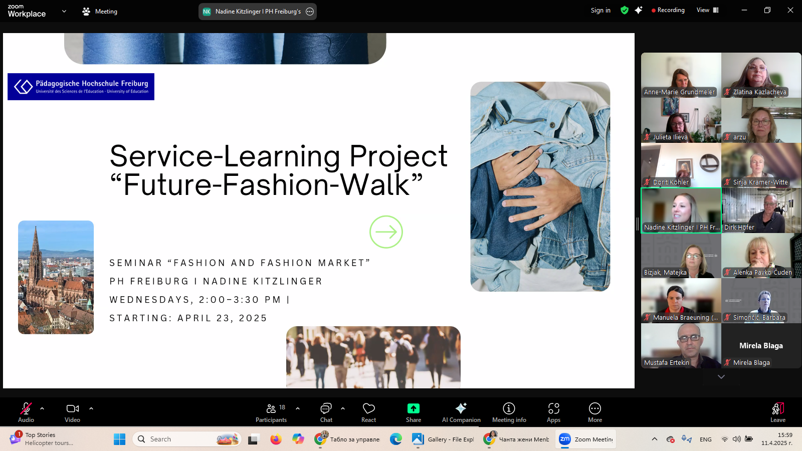

Figure 3. SL project Future Fashion Walk in Freiburg

TexUnite consortium, April 2025